MySQL Relational Database

Езикът за релационни база данни е един с леки диалекти – просто мениджмънт системата за управление на данни е различна – Oracle, MariaDB, MySQL, etc.

<https://www.w3schools.com/sql/sql_where.asp>

За Judge на СофтУни – ако не е зададено другояче, базата данни /схемата не я цитираме като подаваме решенията си в Judge.

# 0. Някои basic неща

MySQL е case insensitive – команди можем да пишем както с големи, така и с малки букви

Слагаме коментари с: # или /*…. */

Ctrl + / - слага в коментар по друг начин

Полета/обекти винаги ограждаме с тилда кавички **`**….**`** като по този начин escape-ваме запазени думи в SQL

Ctlr + D – добавяме един ред като горния ред

Числата въвеждаме без скоби

Текстовете ограждаме с единични обикновени скоби ‘….’

За пари ползваме DECIMAL вместо DOUBLE

NULL

TRUE

FALSE

= присвоява стойност – ДА и знак за сравнение - ДА

SET e_count **:=** присвояване

**!= или <>** значат и двете различно, работи само за числови стойности. Иначе използваме IS NULL / IS NOT NULL

>= по-голямо

<= по-малко

Като кликнем колоните на таблица, то името на колоната се нанася в SQL заявката – да не си играем да пишем ръчно името на колоната

Като цяло, при базите данни, гледаме 90% предварително, и след това пишем заявките.

Ctrl + R – reverse Engineering

Ctrl + Space – Auto suggest

Реално не можем да дебъгваме в MySQL дадена функция/процедура/или какво и да е

+

-

*

/ - обикновено **дробно** делене

% или mod() модулно делене не работи по нормален начин

# 1. Introduction to MySQL

## 1.1. General info

* A database is an **organized** collection of **related** information
  + It imposes **rules** on the contained data
  + Access to data is usually provided by a "**system**" (DBMS) **database** **management**
  + Relational storage first proposed by Edgar Codd in 1970
* **R**elational **D**ata **B**ase **M**anagement **S**ystem
  + Database **management**
  + It **parses requests** from the user and takes the **appropriate** action
  + The user **doesn't have direct access** to the stored data
  + Data is presented by **relations** – collection of tables related by **common fields**
  + MS SQL Server, DB2, Oracle and MySQL

## 1.2. Database Engine Flow

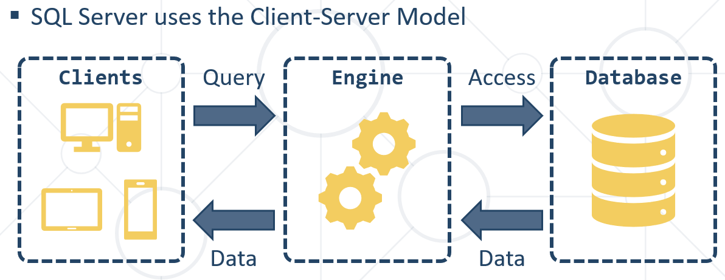

**Client-Server Model**



## 1.3. Structured Query Language = SQL

* + Queries
  + Clauses
  + Expressions
  + Predicates
  + Statements

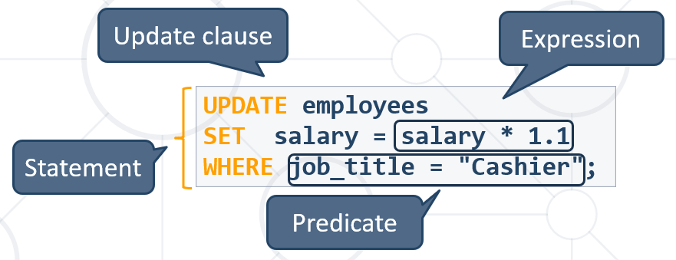

**CRUD** – Create, Read, Update, Delete

* Logically divided in four sections
  + **Data Definition Language**– describe the structure of our data = **DDL**
  + **Data Manipulation Language** – store and retrieve data = **DML**
  + **Data Control Language** – define who can access the data = **DCL**
  + **Transaction Control Language** – bundle operations and allow rollback = **TCL**

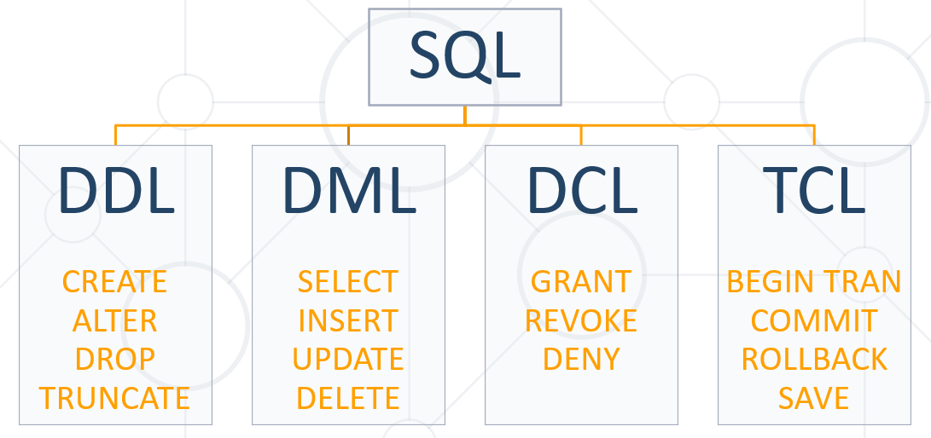

## 1.4. MySQL Server Architecture

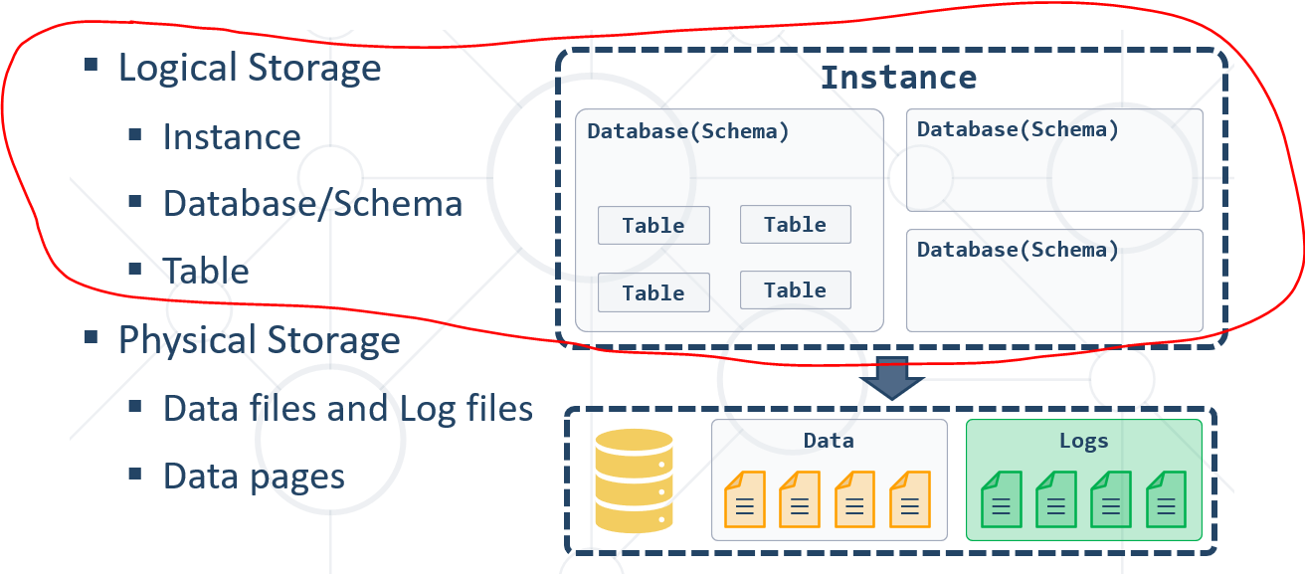

## 1.5. Database Table Elements

* The table is the main **building block** of any database
* Each **row** is called a **record** or **entity**
* Columns (**fields**) define the **type** of data they contain

## 1.6. Table Relationships

* We split the data and introduce **relationships** between the tables to **avoid** repeating information
* Connection via **Foreign Key** in one table pointing to the **Primary** **Key** in another

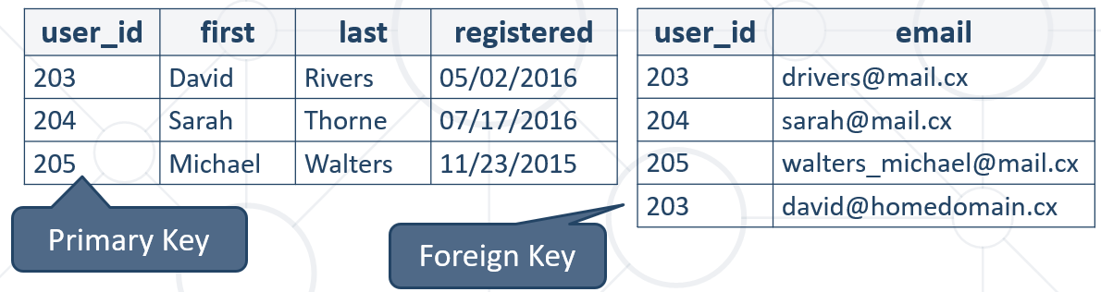

## 1.7. Programmability

### 1.7.1. Indices

* Indices make data lookup faster
  + Clustered – bound to the **primary key**, physically sorts data
  + Non-Clustered – can be **any field**, references the primary index
* Structured as an **ordered tree**

Бинарно дърво – за по-бързо търсене в базата данни

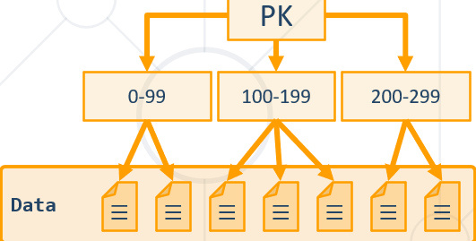

### 1.7.2. Views

* Views are **prepared queries** for displaying **sections** of our data

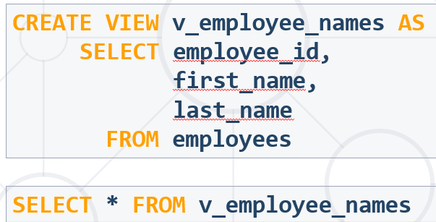

* Evaluated at **run time** – they do not increase performance

### 1.7.3. Procedures, Functions and Triggers

A database can further be customized with reusable code

* **Procedures** – carry out a predetermined **action**
  + E.g. get all employees with salary above 35000
* **Functions** – receive **parameters** and return a **result**
  + E.g. get the age of a person using their birthdate and current date
* **Triggers** – **watch** for activity in the database and **react** to it
  + E.g. when a record is deleted, write it to an archive

## 1.8. Data Types in MySQL Server

### 1.8.1. Numeric Data Types

* Numeric data types have certain range
* Their range can be changed if they are:
  + **Signed** - represent numbers both in the positive **and** negative ranges
  + **Unsigned -** represent numbers **only** in the positive range
* E.g. signed and unsigned INT:

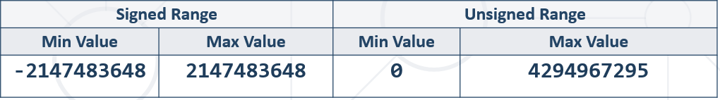

* **INT** [(*M*)] [UNSIGNED] INT(10) – число с 10 цифри
  + **T**INYINT, **S**MALLINT, **M**EDIUMINT, **B**IGINT
* **DOUBLE** [(*M, D*)] [UNSIGNED]



* + E.g. DOUBLE(5, 2) – 999.99 – общо са 5 цифри, като след десетичната запетая са 2 цифри
* **DECIMAL** [(*M, D* )] [UNSIGNED] [**ZEROFILL**] – слага нули отпред ако е нужно

DECIMAL за по-голяма точност

M – общо брой цифри

D- от които след десетичната запетая

### 1.8.2 String Types

String column definitions include attributes that specify the **character set** or **collation**.

* **CHARACTER SET** (Encoding) - Determines the storage of each character (single or multiple bytes)

E.g. utf8, ucs2

* **CHARACTER COLLATION** – rules for encoding comparison - Determines the sorting order and case-sensitivity

E.g. latin1_general_cs, Traditional_Spanish_ci_ai etc

* **Set and collation** can be defined at the database, table or column level

**Non-unicode (just English, western languages)**

* **CHAR** (M) - up to 255 characters
  + fixed-length character type (example CHAR(30) или CHAR(1) )
* **VARCHAR**(M) **–** up to 65 535 characters
  + Variable max size
* **TEXT** – up to 65 535 characters
  + TINYTEXT, MEDIUMTEXT, LONGTEXT
* **BLOB - B**inary **L**arge **Ob**ject [(M)] - 65 535 (216 − 1) characters – когато не пазим адреса/пътя към снимката, а пазим битовата символна версия от 1000+ символа на самата снимка
  + TINYBLOB, MEDIUMBLOB, LONGBLOB

TINYBLOB : L < 2^8 = 256 Bytes

BLOB : L < 2^16 = 65,536 Bytes

MEDIUMBLOB : L < 2^24 = 16,777,216 Bytes

LONGBLOB : L < 2^32 = 4,294,967,296 Bytes

fieldName Blob(size in bytes) -

The short answer **is**: **VARCHAR is** variable length, while **CHAR is** fixed length. **CHAR is** a fixed length string data type, so any remaining space **in the** field **is** padded with blanks. **CHAR** takes up 1 byte per character. ... **VARCHAR is** a variable length string data type, so it holds only the characters you assign to it.

**Двойно повече място за Unicode (all languages worldwide)** - Supports many client computers that are running different locales.

nchar/nvarchar - произлиза от national

|  |  |  |  |  |
| --- | --- | --- | --- | --- |
|  | **char** | **nchar** | **varchar** | **nvarchar** |
| Character Data Type | Non-Unicode fixed-length | Unicode fixed-length can store both non-Unicode and Unicode characters (i.e. Japanese, Korean etc.) | Non-Unicode variable length | Unicode variable length can store both non-Unicode and Unicode characters (i.e. Japanese, Korean etc.) |
| Maximum Length | up to 8,000 characters | up to 4,000 characters | up to 8,000 characters | up to 4,000 characters |
| Character Size | takes up 1 byte per character | takes up 2 bytes per Unicode/Non-Unicode character | takes up 1 byte per character | takes up 2 bytes per Unicode/Non-Unicode character |
| Storage Size | n bytes | 2 times n bytes | Actual Length (in bytes) | 2 times Actual Length (in bytes) |
| Usage | use when data length is constant or fixed length columns | use only if you need Unicode support such as the Japanese Kanji or Korean Hangul characters due to storage overhead | used when data length is variable or variable length columns and if actual data is always way less than capacity | use only if you need Unicode support such as the Japanese Kanji or Korean Hangul characters due to storage overhead |
|  |  |  | query that uses a varchar parameter does an index seek due to column collation sets | query that uses a nvarchar parameter does an index scan due to column collation sets |

### 1.8.3. Date Types

* **DATE -** for values with a date part but **no time part -** 'YYYY-MM-DD' or 'YY-MM-DD'
* **TIME -** for values with time but **no date part –** ’hh: mm: ss’
* **DATETIME -** values that contain both date **and** time parts - ‘YYYY-MM-DD hh: mm: ss’
* **TIMESTAMP -** both date **and** time parts
* MySQL retrieves values for a given date type in a **standard output format**

E.g. as a string in either 'YYYY-MM-DD' or 'YY-MM-DD'

**ВАЖНО**

Когато сравняваме дата DATE с DATESTAMP, изречението „hired after 1/1/1999“ го тълкуваме

WHERE e.`hire_date` >= '1999-01-02'

защото имаме DATESTAMP 1999-12-12 **01:26**:00.000000

### 1.8.4. Boolean Types

`gender` **BOOLEAN**;

CREATE TABLE `people`(

`id` INT NOT NULL UNIQUE AUTO_INCREMENT PRIMARY KEY,

`name` VARCHAR(200) NOT NULL,

`picture` MEDIUMBLOB,

`height` DOUBLE(5,2),

`weight` DOUBLE(5,2),

`gender` CHAR(1) NOT NULL,

`birthdate` DATE NOT NULL,

`biography` LONGTEXT

);

## 1.9. **DDL – Data Definition Language** - Database Modelling – using GUI or via basic SQL queries

**Да даваме Refresh от време на време**

* **Working with IDEs – MySQL Workbench** Database ManagementSystem - we can use GUI Clients to **create** and **customize** tables
* Enables us:
  + To **create** a new database
  + To create **objects in the database** (tables, stored procedures, relationships and others)
  + To **change** the properties of objects
  + To **enter records** into the tables

### 1.9.0. Creating a New Database

* Select **Create new schema** from the command menu

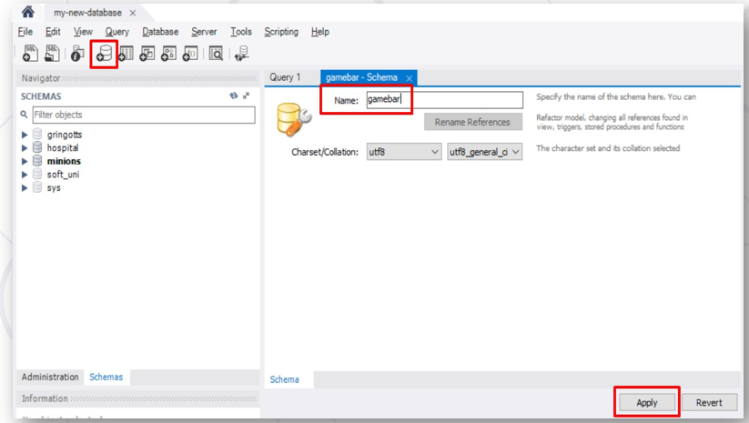

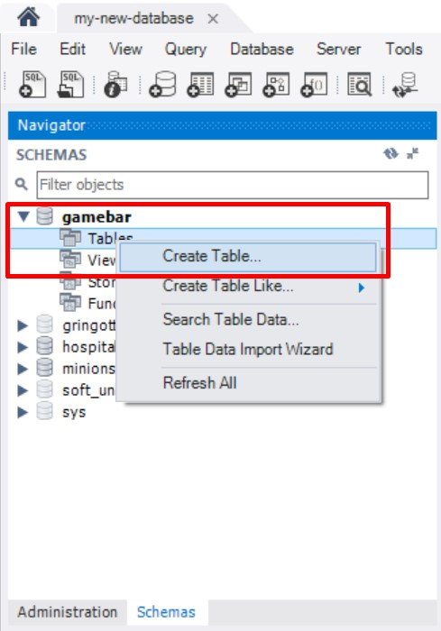

* **A Primary Key is used to uniquely identify and index records**

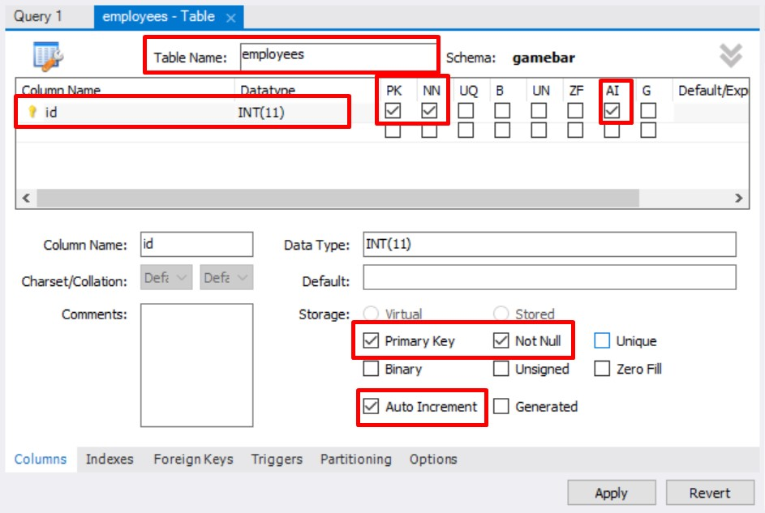

### 1.9.1. Foreign keys

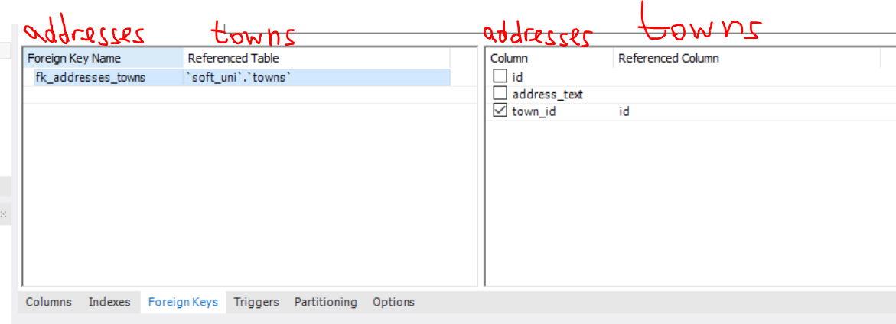

* **Adding foreign keys**

A FOREIGN KEY is a field (or collection of fields) in one table, that refers to the PRIMARY KEY in another table.

**The table with the foreign key is called the child table, and the table with the primary key is called the referenced or parent table.**

Конвенция при изписване на foreign key поле: fk_fromMinions_toTowns

В minions е чуждия ключ, а в Towns е primary ключ.

ВАЖНО: когато създаваме foreign keys, първо трябва да създадем таблицата, от която foreign key ще взема данни.

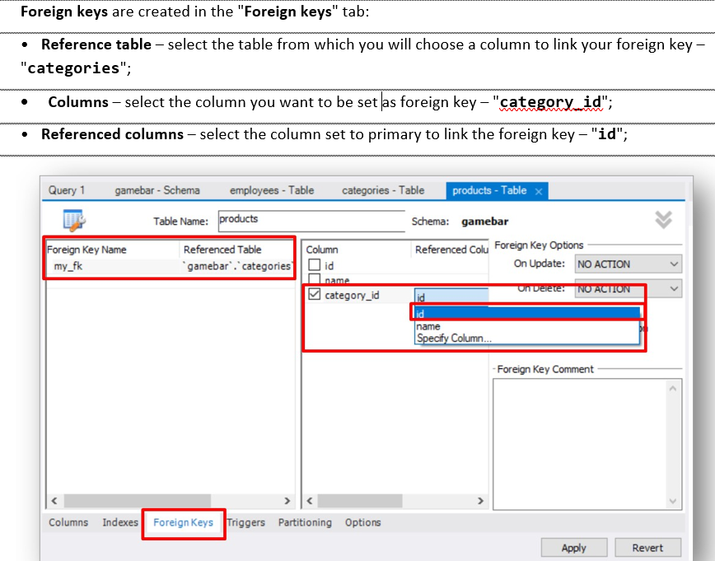

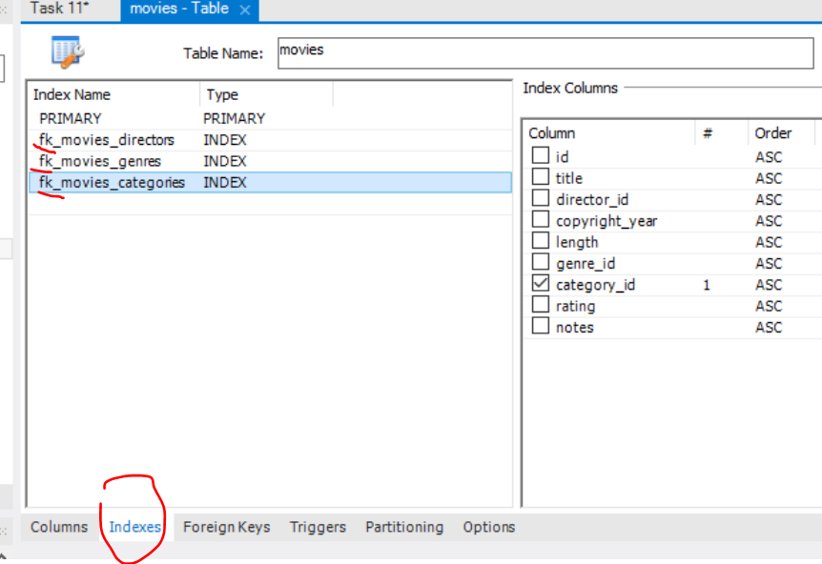

CREATE TABLE `Orders` (  
    `OrderID` int NOT NULL,  
    `OrderNumber` int NOT NULL,  
    `PersonID` int,  
    PRIMARY KEY (`OrderID`),

CONSTRAINT `fk_source_target`  
    FOREIGN KEY `Orders`(`PersonID`)

REFERENCES `Persons`(`PersonID`)  
);

SQL FOREIGN KEY on ALTER TABLE

ALTER TABLE `products`

ADD CONSTRAINT `fk_products_categories`

FOREIGN KEY `products`(`category_id`)

REFERENCES `categories`(`id`);

ALTER TABLE `minions`.`minions`

ADD CONSTRAINT `fk_minions_towns`

FOREIGN KEY (`town_id`)

REFERENCES `minions`.`towns` (`id`);

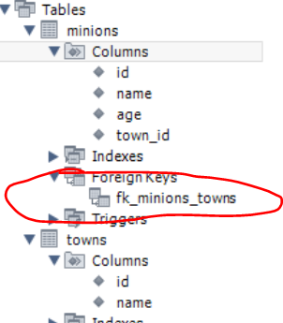

### 1.9.2. Where to run our SQL queries

Working with basic SQL queries

* We communicate with the database engine using SQL
* Queries provide greater **control** and **flexibility**

**Queries are written in the "Query" tab.**

**Database creation**

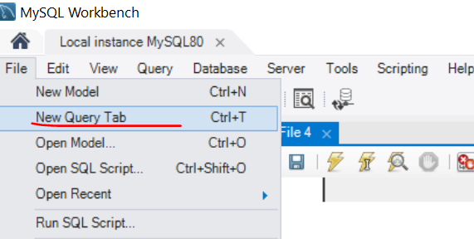

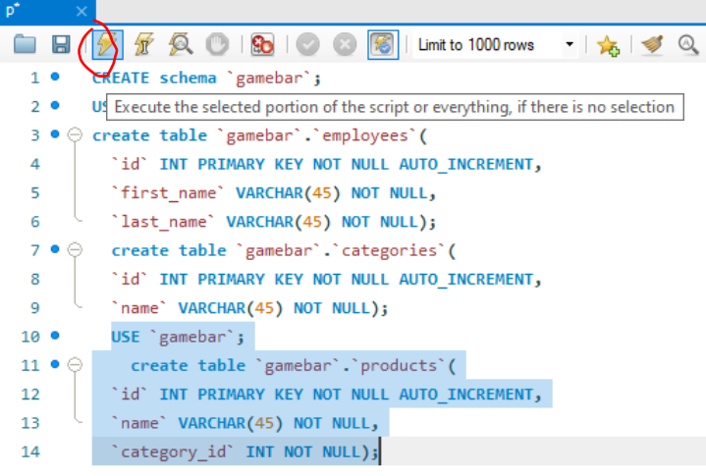

**CREATE DATABASE** `gamebar`; или **CREATE SCHEMA** `gamebar`;

Ако искаме да отворим съществуващ SQL script, то правилния начин и е цъкнем **File -> Open SQL script**

### 1.9.3. Table Creation in SQL:

В работната част gamebar, създай таблица employees – за графично, виж скрийншота по-горе

The command **USE** – ако имаме отворени няколко база данни, да знаем с коя работим

**USE** `gamebar`

**CREATE TABLE** `gamebar`.`employees` (

`id` **INT NOT NULL AUTO_INCREMENT**,

`name` **VARCHAR(45) NOT NULL**,

**PRIMARY KEY** (`id`));

Или

**create table** `gamebar`.`categories`(

`id` **INT PRIMARY KEY NOT NULL AUTO_INCREMENT**,

`name` **VARCHAR(45) NOT NULL**);

**Sugar syntaxis for AUTO_INCREMENT** – задаване на първоначална стойност, от която да започне да инкрементира с единица:

CREATE TABLE models (

`model_id` INT AUTO_INCREMENT UNIQUE NOT NULL,

`name` VARCHAR(20) NOT NULL,

`manufacturer_id` INT NOT NULL

) **AUTO_INCREMENT** = 101; //започни от 101 като първи запис

### 1.9.4. Add records in SQL:

#### Option 1 – през графични interface

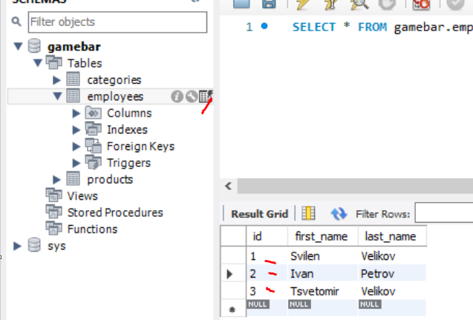

#### Опция 2 – с SQL заявка и hardcore-нати стойности

**INSERT INTO** `gamebar`.`employees` (`id`, `first_name`, `last_name`) **VALUES** ('1', 'Svilen', 'Velikov');

**INSERT INTO** `gamebar`.`employees` (`id`, `first_name`, `last_name`) **VALUES** ('2', 'Ivan', 'Petrov');

**INSERT INTO** `gamebar`.`employees` (`id`, `first_name`, `last_name`) **VALUES** ('3', 'Tsvetomir', 'Velikov');

**Или така:**

INSERT INTO `towns` (`id`, `name`)

VALUES

(1, 'Sofia'),

(2, 'Plovdiv'),

(3, 'Varna');

**Или ако вкарваме всичко:**

INSERT INTO `towns` пропускаме скобите или слагаме само празни скоби

VALUES

(1, 'Sofia'),

(2, 'Plovdiv'),

(3, 'Varna');

#### Опция 3 – с SQL заявка, без VALUES и с функция за определяне/за автоматично попълване

**Пример 1**

**INSERT INTO** cards(card_number, card_status, bank_account_id)

**(**без тези скоби в judge

**SELECT** REVERSE(full_name), 'Active', id

FROM clients

WHERE id>=191 AND id<=200

**);** без тези скоби в judge

**Пример 2**

INSERT INTO `coaches`(`first_name`, `last_name`, `salary`, `coach_level`)

SELECT `first_name`, `last_name`, `salary`,

CHAR_LENGTH(`first_name`)

FROM `players`

WHERE `age` >= 45;

**Пример 3**

INSERT INTO cards(card_status, card_number, bank_account_id)

( без тези скоби в judge

SELECT (

CASE

WHEN id BETWEEN 191 AND 199 THEN 'Active'

WHEN id BETWEEN 200 AND 299 THEN 'Inactive'

WHEN id BETWEEN 300 AND 500 THEN 'Deleted'

END

) AS customs_status, REVERSE(full_name), id

FROM clients

); без тези скоби в judge

### 1.9.5. Correcting/Updating records in SQL

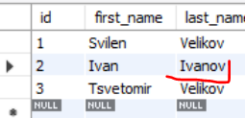

**UPDATE** `gamebar`.`employees` **SET** `last_name` = 'Ivanov' **WHERE** (`id` = '2');

**Възможност в WHERE да не участва ключовото поле: Preferences -> SQL Editor**

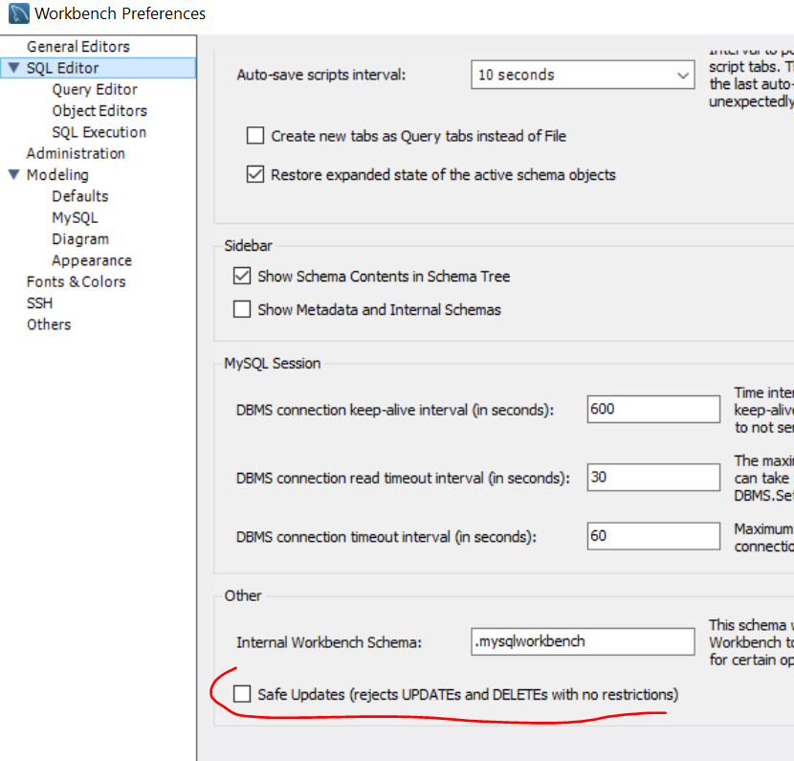

### 1.9.6. Deleting data in SQL:

* Deleting structures is called **dropping**
  + You can drop **keys**, **constraints**, **tables** and entire **databases**
* Deleting all data in a table is called **truncating**
* Both of these actions **cannot be undone** – use with caution!
* **Deleteing row**

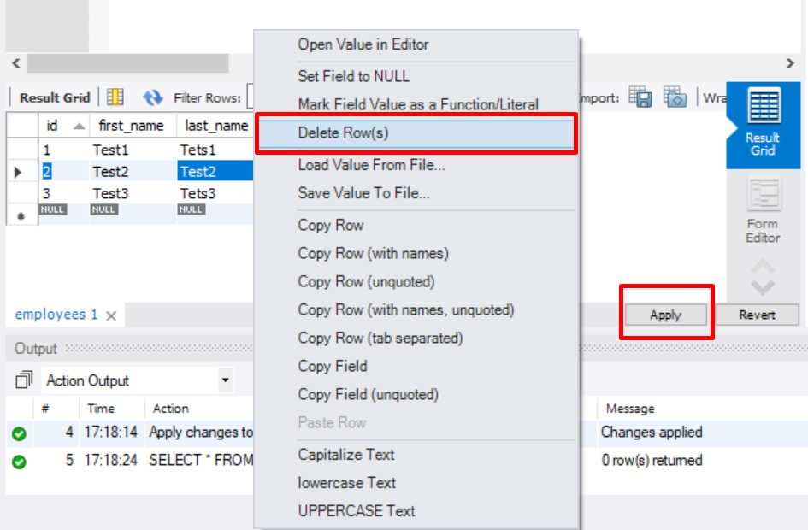

**DELETE FROM** `gamebar`.`employees` **WHERE** (`id` = '2');

* **To delete all the entries in a table, but keep the table structure**

**TRUNCATE TABLE** employees**;**

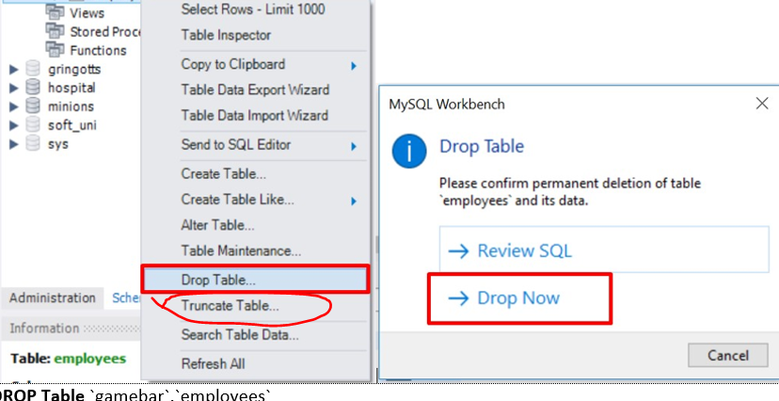

* **Dropping table - delete data and structure**

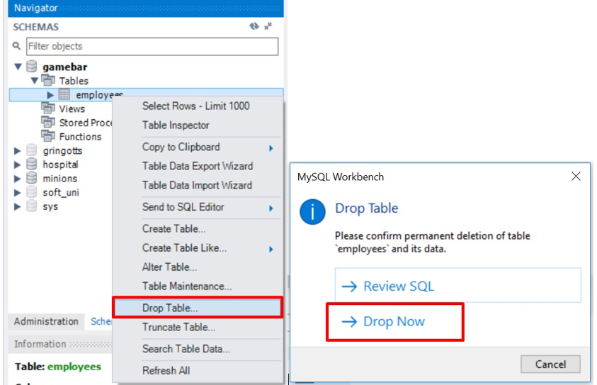

**DROP** **Table** `gamebar`.`employees`

* **Dropping the entire Database**

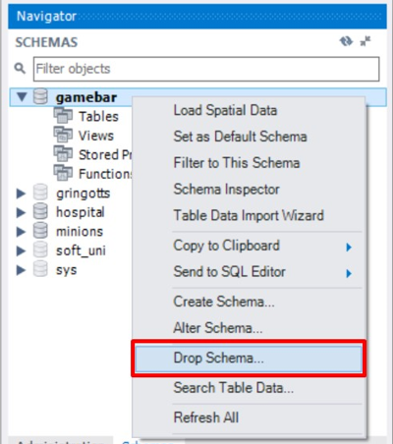

**DROP DATABASE** `gamebar`

* **To remove a constraining rule from a column**
  + Primary keys, value constraints and unique fields

**ALTER TABLE** employess **DROP CONSTRAINT** pk_id**;**

* **To remove DEFAULT value (**if not specified, revert to NULL**)**

**ALTER TABLE** employess

**ALTER COLUMN** clients

**DROP DEFAULT;**

### 1.9.7. Retrieve Records in SQL:

* Get all information from a table

**SELECT * FROM** towns; - покажи текущите записи в базата данни от таблица towns.

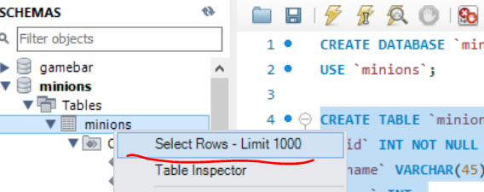

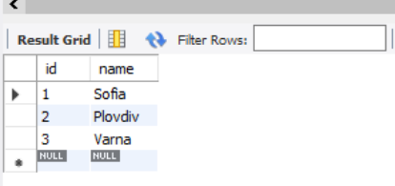

* **You can limit the columns and number of records**

**SELECT** first_name, last_name **FROM** employees **LIMIT** 5; - ограничи до 5 записа

## 1.10. Table Customization

Primary Key

**id INT PRIMARY KEY;**

**Not null – държим да има запис в това поле**

**id INT NOT NULL PRIMARY KEY;**

Auto-Increment (Identity)

**id INT AUTO_INCREMENT PRIMARY KEY;**

Unique constraint – no repeating values in entire table

**email VARCHAR(50) UNIQUE;**

Default value – if not specified (otherwise set to **NULL**)

**balance DECIMAL(10,2) DEFAULT 0;**

## 1.11. Altering Tables

### A table can be changed using the keywords ALTER TABLE

**ALTER TABLE** employees**;**

### Add new column

**ALTER TABLE** employees **ADD** salary DECIMAL**; -** добавя колона salary от тип Decimal

**ALTER TABLE** `gamebar`.`employees`

**ADD COLUMN** `middle_name` **VARCHAR(45) NOT NULL** AFTER `last_name`;

**ALTER TABLE `users`**

**ADD COLUMN `pk_users` VARCHAR(45) NOT NULL AFTER `id`;**

### Changing type of a column / changing name of a column

**ALTER TABLE** `minions`.`towns`

**CHANGE COLUMN** `town_id` `id` **INT NOT NULL** AUTO_INCREMENT **;**

### Delete existing column – изтрива колона

**ALTER TABLE** people **DROP COLUMN** full_name**;**

**ALTER TABLE `users` DROP COLUMN `pk_users`;**

### Modify data type of existing column

**ALTER TABLE** people **MODIFY COLUMN** emailVARCHAR(100)**; -** колоната email става от нов тип

### Add primary key to existing column

**ALTER TABLE** people **ADD CONSTRAINT PRIMARY KEY();**  - Constraint name

**PRIMARY KEY (**id**); -** Column name (more than one for composite key)

ALTER TABLE `users` ADD CONSTRAINT PRIMARY KEY(`pk_users`);

### Deleting primary key from a table

**ALTER TABLE** people

**DROP PRIMARY KEY; -** Column name (more than one for composite key)

ALTER TABLE `users`

DROP PRIMARY KEY;

### **Add constraint / Add unique constraint**

**ALTER TABLE** people **ADD CONSTRAINT** uq_email - Constraint name

**UNIQUE (**email**)**; - columns names

Това не копира обединени данни в колона `pk_users`, прави следното – задай ограничение pk_users, което да е primary key от id и username

ALTER TABLE `users`

DROP PRIMARY KEY,

ADD CONSTRAINT `pk_users`

PRIMARY KEY `users`(`id`, `username`);

**ALTER TABLE `users`**

**DROP PRIMARY KEY,**

**ADD CONSTRAINT `pk_users`**

**PRIMARY KEY `users`(`id`),**

**CHANGE COLUMN `username` `username` VARCHAR(50) UNIQUE;**

### **Set default value**

**ALTER TABLE** people **ALTER COLUMN** balance **SET DEFAULT** 0;

* Set default value – вариант 2

**ALTER TABLE** `users`

**CHANGE COLUMN** `last_login_time` `last_login_time` **DATETIME NULL DEFAULT CURRENT_TIMESTAMP ;**

**Старо ново**

От типа данни на NOW()

**ALTER TABLE `users`**

**CHANGE COLUMN `last_login_time` `last_login_time` DATETIME NULL DEFAULT NOW() ;**

**ALTER TABLE `users`**

**CHANGE COLUMN `username` `username` VARCHAR(30) NOT NULL DEFAULT 'Bai Peshu Starshi' ;**

## 1.12. How to cheat – to see the SQL query

Create Statement – използваме го, за да създадем лесно SQL Заявка без да пишем всичко ръчно

Insert Statement – използваме го, за да видим SQL заявката, на това което сме създали

Update Statement – използваме го, за да обновим базата данни/да обновим поле/таблица

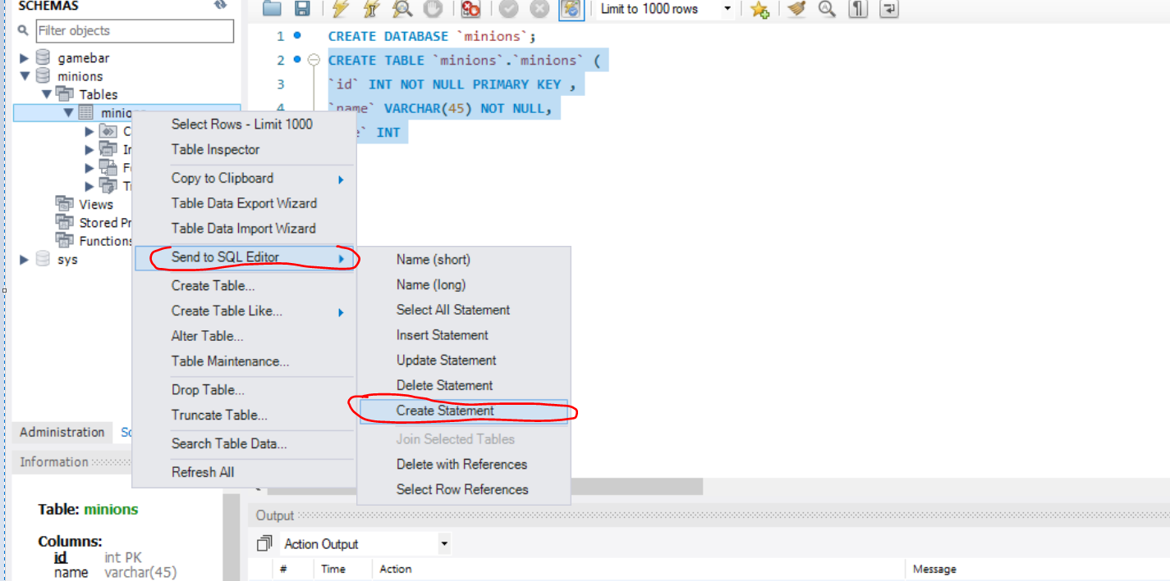

## 1.13. Advanced SQL queries

Сортира в alphabetic ред

SELECT `name` FROM `towns`

**ORDER BY** `name`; -

Сортира Double в низходящ ред

**SELECT** * **FROM** `employees`

**ORDER BY** `salary` **DESC;**

**ORDER BY** `salary`е същото като **ORDER BY** `salary` **ASC**

Тo show sorted only **some of the columns**

**SELECT** `first_name`, `last_name`, `job_title`, `salary` from `employees`

**ORDER BY** `salary` **DESC;**

**Нанасяне на нова информация на даден ред за дадена колона – за всички записи**

**UPDATE** `employees`

**SET** `salary` = `salary` * 1.1;

**WHERE** `id` > 0**;**

**Нанасяне на нова информация на даден ред за дадена колона – за определен запис**

**UPDATE** `employees`

**SET** `salary` = `salary` * 1.1;

**WHERE** `id` = 5**;**

### 1.14. E/R Diagram – диаграма на свързаността

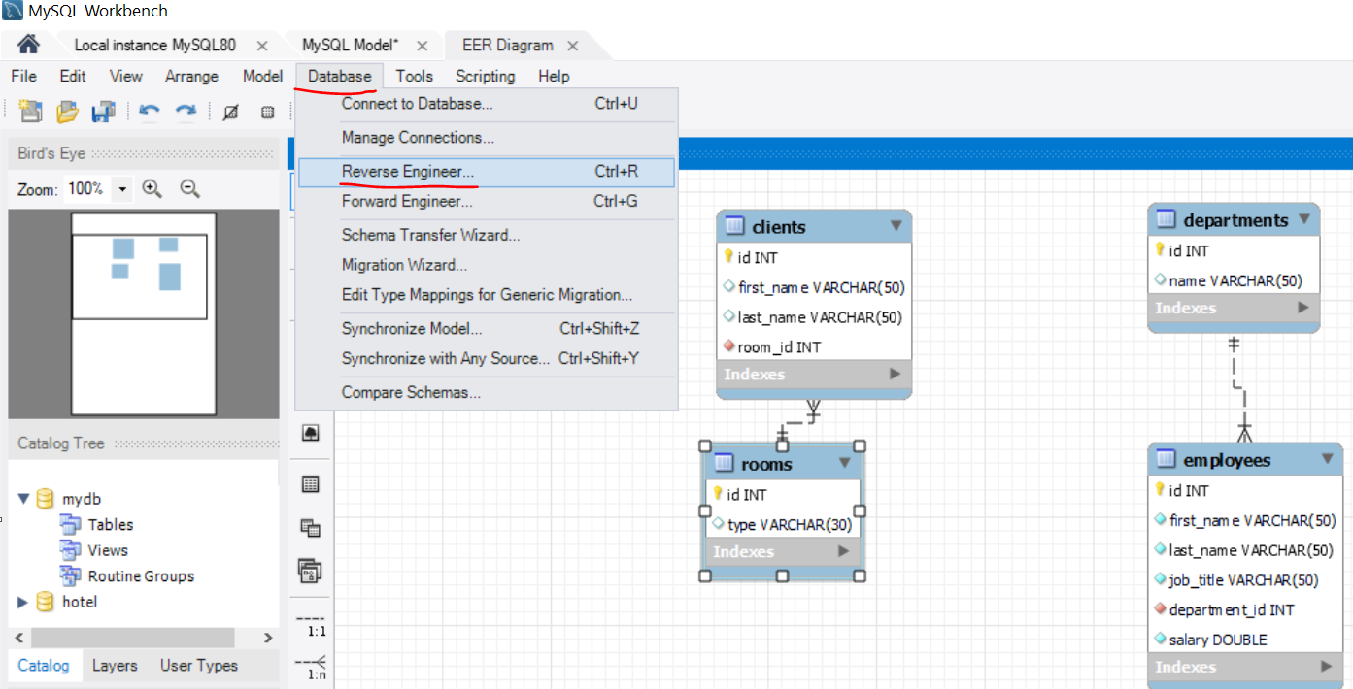

# 2. BASIC CRUD (Create,Read,Update, Delete) OPERATIONS – DML – Data Manipulation Language

## 2.1. Query Basics

* Select first, last name and job title about employees:

**SELECT `**first_name`, `last_name`, `job_title` **FROM `**employees`**;**

* Select projects which start on 01-06-2003:

**SELECT * FROM `**projects` **WHERE `**start_date`='2003-06-01'**;**

* Inserting data into table – можем да insert-нем определени колонки, но тези които изпускаме не трябва да са NOT NULL. А тези, които са AUTO_INCREMENT – сами се увеличават дори да не вкарваме данни за тях

**INSERT INTO** projects(`name`, `start_date`)

**VALUES(**'Introduction to SQL Course', '2006-01-01'**);**

**Опция 3 – с SQL заявка и функция за определяне/за автоматично попълване**

**INSERT INTO** cards(card_number, card_status, bank_account_id)

**(**

SELECT REVERSE(full_name), 'Active', id

FROM clients

WHERE id>=191 AND id<=200

**);**

* Update several cells for specific rows:

**UPDATE `**projects`

**SET `**end_date` = '2006-08-31', `id` = 3;

**WHERE `**start_date` = '2006-01-01';

* Update specific cells/columns for all rows/records:

**UPDATE** `employees`

**SET** `salary` = `salary` * 1.1;

* Delete specific projects – изтрива целия ред

**DELETE FROM `**projects`

**WHERE `**start_date` = '2006-01-01';

## 2.2. Retrieving Data

#### Capabilities of SQL SELECT

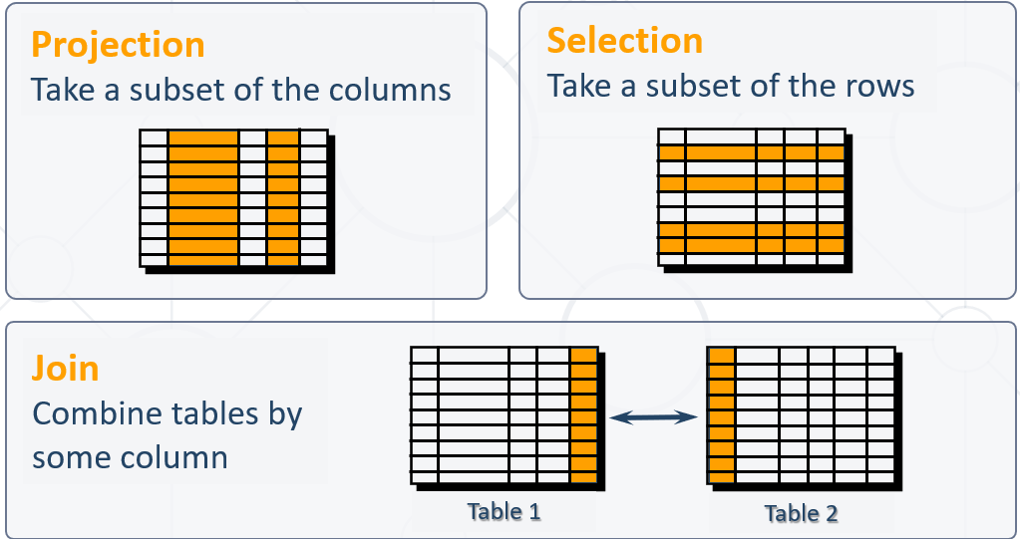

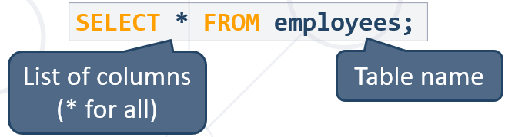

**SELECT `**id`, `first_name`, `last_name`, `job_title`

**FROM `**employees`

**ORDER BY `**id`;\

**WHERE**

**LIMIT 3;**

Всички колони плюс още колони

**SELECT *,`**id`, `first_name`, `last_name`, `job_title`

**FROM `**employees`

**ORDER BY `**id`;\

**WHERE**

**LIMIT 3;**

#### **Aliases(прякор/друго име)** rename a table or a column heading – **използваме задължително когато работим с повече от една таблица!!!**

**ВАЖНО – когато искаме да работим с колоната aliases – прякото име, то след AS използваме обикновени кавички ‘’, но в последствие използваме специалните кавички `` - НЕЕЕ Е ТАКА, МОЖЕ ДА СИ ИЗПОЛЗВАМЕ САМО ТИЛДА КАВИЧКИ!**

**SELECT** e.id **AS** 'No.',

e.first_name **AS** 'First Name',

e.last_name **AS** 'Last Name',

e.job_title **AS** 'Job Title'

**FROM** employees **AS** e

**ORDER BY** `Job title`;

Пример за Aliases когато работим едновременно с 2 таблици:

**SELECT** p.`peak_name`,

r.`river_name`,

**LOWER**(**CONCAT**(p.`peak_name`, **SUBSTRING**(r.`river_name`, 2))) **AS** `mix`

**FROM** `peaks` **AS** p, `rivers` **AS** r

**WHERE** **RIGHT**(**LOWER**(p.`peak_name`), 1) = **LEFT**(**LOWER**(r.`river_name`), 1)

**ORDER BY** `mix`;

**SELECT**

5+5 **AS** 'staticnumber',

`job_title` **AS** 'Job Title',

`id` **AS** 'No.'

**FROM `**employees**`;**

#### Concatenation – когато ги обединява в резултата от SELECT

**concat()** - returns the string that results from concatenating the arguments  - предефинирана функция в MySQL

* + String literals are enclosed in [**'**](**single** **quotes**)
  + Table and column names containing special symbols use [**`**] (**backtick**)

**SELECT concat**(`first_name`,' ',`last_name`**) AS** 'full_name'**,**

`job_title` **AS** 'Job Title',

`id` **AS** 'No.'

**FROM `**employees**`;**

#### Another function of concatenation is **concat_ws()** - stands for concatenate with **separator** and is a special form of **CONCAT()** – с първия стринг лепим останалите

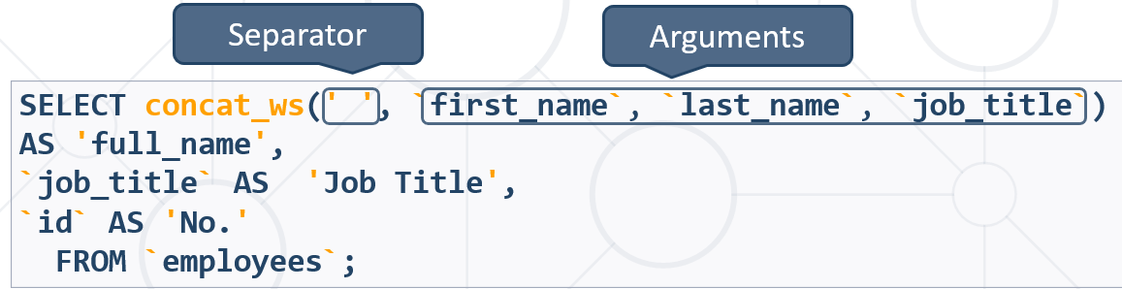

* Skip any **NULL** values after the separator argument.

#### Concatennating with + : Add 2 strings together:

Не работи както трябва

#### Filtering the Selected Rows

* Use **DISTINCT** to eliminate duplicate results – to eliminate all the duplicate records and fetching only unique records.

**SELECT DISTINCT** `first_name`

**FROM** `employees`;

Ако има повтарящи се имена, то покажи само веднъж повтарящото се име

* You can filter rows by specific conditions using the **WHERE** clause

**SELECT** `last_name`, `department_id`

**FROM** `employees`

**WHERE** `department_id` = 1;

* Other **logical operators** can be used for better control

**SELECT** `last_name`, `salary`

**FROM** `employees`

**WHERE** `salary` <= 20000;

* Conditions can be combined using **NOT**, **OR**, **AND** and brackets

**SELECT** `last_name` **FROM** `employees`

**WHERE NOT** (`manager_id` = 3 **OR** `manager_id` = 4);

* Using **BETWEEN** operator to specify a range:

**SELECT** `last_name`, `salary` **FROM** `employees`

**WHERE** `salary` **BETWEEN** 20000 **AND** 22000**; - работи включително**

**HAVING** `max_salary` **NOT BETWEEN** 30000 **AND** 70000

* Using **IN / NOT IN** to specify a set of values:

**SELECT** `first_name`, `last_name`, `manager_id`

**FROM** `employees`

**WHERE** `manager_id` **IN** (109, 3, 16); - **дали е измежду тези стойности**

SELECT * FROM `towns`

WHERE LOWER(SUBSTRING(`name`,1,1)) NOT IN('r', 'b', 'd')

ORDER BY `name`;

#### Comparing with NULL

* **NULL** is a special value that means missing value
  + Not the same as **0** or a blank space
* Checking for **NULL** values

Проверка за различно по този начин **!=** и по този начин **<>** не можем да правим с NULL!!!

**SELECT** `last_name`, `manager_id`

**FROM** `employees`

**WHERE** `manager_id` = **NULL; -ГРЕШНО!**

**SELECT** `last_name`, `manager_id`

**FROM** `employees`

**WHERE** `manager_id` **IS NULL;**

**SELECT** `last_name`, `manager_id`

**FROM** `employees`

**WHERE** `manager_id` **IS NOT NULL;**

#### Sorting with ORDER BY – може по две условия, отделяме със запетая

* Sort rows with the **ORDER BY** clause
  + **ASC**: ascending order, default
  + **DESC**: descending order

**SELECT** `last_name`, `hire_date`

**FROM** `employees`

**ORDER BY** `hire_date` **DESC, `**last_name` **ASC;**

Ако `hire_date` съвпада, то сортирай по следващ критерий **`**last_name`

#### Сортираме по много условия – отделяме със запетая

SELECT * FROM `employees`

ORDER BY `salary` DESC, `first_name` ASC, `last_name` DESC, `middle_name` ASC, `employee_id`;

#### Views – все едно си запазваме предефинирана заявка

* Views are **virtual tables** made from others tables, views or joins between them
* Usage:
  + To simplify writing complex queries
  + To limit access to data for certain users

**Views** – Example 1

**CREATE VIEW** `v_hr_result_set` **AS  
SELECT**

**CONCAT**(`first_name`,' ',`last_name`) **AS** 'Full Name',

`salary`

**FROM** `employees` **ORDER BY** `department_id`**;**

**SELECT * FROM** `v_hr_result_set`;

Example 2

**CREATE VIEW** `myview` **AS**

**SELECT** `first_name`, 5 **FROM** `employees`

**ORDER BY** `salary` **DESC**, `first_name` **ASC**, `last_name` **DESC**;

**SELECT * FROM** `myview`;

**DROP VIEW** `myview`; - заличи

## 2.3. Writing Data in Tables

#### The SQL **INSERT** command

**INSERT INTO** `towns` **VALUES** (33, 'Paris'); **- values for all columns сме длъжни да подадем**

**INSERT INTO** projects(`name`, `start_date`) - кажи колко колони ще нанасяш

**VALUES** ('Reflective Jacket', NOW())

Inserting data into table – можем да insert-нем определени колонки, но тези които изпускаме не трябва да са NOT NULL. А тези, които са AUTO_INCREMENT – сами се увеличават дори да не вкарваме данни за тях

#### **Bulk** **data** can be recorded in a single query, separated by comma

INSERT INTO `towns` (`id`, `name`)

VALUES

(1, 'Sofia'),

(2, 'Plovdiv'),

(3, 'Varna');

#### You can use existing records to create a **new table – копира както структурата, така и данните**

##### Пример 1

**CREATE TABLE** `customer_contacts`- new table name

**AS SELECT** `customer_id`, `first_name`, `email`, `phone`

**FROM** `customers`; - from existing table

##### Пример 2

**CREATE TABLE** `workers` **AS**

**SELECT** `first_name` **FROM** `employees`;

**CREATE TABLE** auto_filled **AS**

**SELECT** e.`first_name`,

d.`name` AS 'dept_name'

**FROM** `employees` AS e

**INNER JOIN** `departments` AS d

**ON** e.`department_id` = d.`department_id`;

#### **You can write into an existing table - – копира както структура, така и данни**

##### Пример 1

**INSERT INTO `**projects`(`name`, `start_date`)

**SELECT**

**CONCAT**(`name`,' ', ' Restructuring'),

NOW()

**FROM `**departments`;

Копира ги/добвя ги като данни за нови елементи от таблицата …. ☹

INSERT INTO `users`(`pk_users`)

SELECT

CONCAT(`id`, '',`username`) FROM `users`;

##### Пример 2

**CREATE TABLE** `workers`;

**INSERT INTO** `workers`

**SELECT** `first_name` **FROM** `employees` **WHERE** `salary` < 1000;

## 2.4. Updating Existing Records – UPDATE & DELETE

#### Updating data

##### The SQL **UPDATE** command

**UPDATE** `employees`

**SET** `last_name` = 'Brown'

**WHERE** `employee_id` = 1;

**UPDATE** `employees`

**SET** `salary` = `salary` * 1.10,

`job_title` = **CONCAT**('Senior',' ', `job_title`)

**WHERE** `department_id` = 3;

* Note: Don't forget the **WHERE** clause!

#### Deleting Data

* Deleting specific rows from a table
  + Note: Don't forget the **WHERE** clause!

**DELETE FROM** `employees`

**WHERE** `employee_id` = 1;

* Delete all rows from a table (**TRUNCATE** works faster than **DELETE)**

**TRUNCATE TABLE `users`;**

# 3.Built-in functions

<https://dev.mysql.com/doc/refman/8.0/en/functions.html> - функции, има и .xml functions и .json functions

## **3.1. String functions**

* **SUBSTRING()** – extracts part of a string

**SUBSTRING(***String*, *Position***) – позицията/броенето започва от 1, а не от 0-левия**

**SUBSTRING(***String*, *Position*, *Length***)**

**SUBSTRING(***String* FROM *Position* FOR *Length***)**

SELECT SUBSTRING('SoftUni', 2); - връща 'oftUni'

SELECT SUBSTRING('SoftUni', 2, 3); - връща 'oft'

* **REPLACE** – replaces specific string with another
  + Performs a case-sensitive match

**REPLACE(***String*, *Pattern*, *Replacement***)** Pattern - string to replace replacement – with what to replace

SELECT **REPLACE**(`title`, 'The', '***')

AS 'Title' FROM `books`

WHERE **SUBSTRING**(title, 1, 3) = 'The';

SELECT REPLACE(`title`, 'The', '***')

AS `title` FROM `books`

WHERE `title` **LIKE** 'The%'

ORDER BY `id` ASC;

SELECT `first_name`, `last_name` FROM `employees`

WHERE **LOWER**(`job_title`) **NOT LIKE** '%engineer%'

ORDER BY `employee_id`;

* **Кастване/конвертиране от число към стринг**

**CAST** (1 as **CHAR**)

* **Chaining на функции –** една функция в друга
* **LTRIM & RTRIM –** remove spaces from either side of string

**LTRIM(***String***) –** от началото на стринга

**RTRIM(***String***)** – от края на стринга

* **CHAR_LENGTH –** count number of characters

**CHAR_LENGTH(***String***)**

SELECT `name` FROM `towns`

WHERE **CHAR_LENGTH**(`name`) IN(5,6)

ORDER BY `name` ASC;

* **LENGHT –** get number of used bytes (double for Unicode)

**LENGTH(**String**)**

Кирилицата заема по 2 байта, а латиницата по един

SELECT LENGTH('асц'); - връща 6

SELECT LENGTH('bdt'); - връща 3

* **LEFT & RIGHT** – get characters from beginning or end of string

**LEFT(***String*, *Count***) – от края**

**RIGHT(***String*, *Count***) – от началото**

SELECT `id`, `start`,

**LEFT**(`name`, 3) AS 'Shorthand'

FROM `games`;

* **LOWER & UPPER –** change letter casing – we use it for case insensitive search

**LOWER(***String***)**

**UPPER(***String***)**

* **REVERSE** – reverse order of all characters in string

**REVERSE(***String***)**

* **REPEAT –** repeat string

**REPEAT(***String, Count***)**

* **LOCATE –** locate specific pattern (substring) in string

**LOCATE(***Pattern, String,[Position]***) -** If omitted(пропуснато), position begins at 1

SELECT **LOCATE**('Big', `title`) FROM `books`; - връща позицията на която се появява Big в полето `title`. **Ако не намери, връща 0**

SELECT LOCATE('@', 'chavdar.mitkov@softuni.bg'); - връща 15

SELECT LOCATE('@', 'chavdar.mitkov@softu@ni.bg', 16); - връща 22

SELECT `user_name`, SUBSTRING(`email`, LOCATE('@', `email`)+1) AS `email provider` FROM `users`

ORDER BY `email provider` ASC, `user_name` ASC;

* **INSERT** – insert substring at specific position

**INSERT(***StringToInsertInto, Position, Length, Substring***)** като Length e броят символи за унищожение

SELECT INSERT(`title`, 1, 0, 'Ordered book: ') FROM `books`; **- вмъкни на позиция 1, без да триеш нищо(0) ‘Ordedered book: ’ пред всяко заглавие на книга**

SELECT *,

INSERT (`title`, LOCATE('Big', `title`), 3, 'Small') AS `newtitle` - новото заглавие ако съдържа Big, то го подмени с ‘Small’

FROM `books`

WHERE `title` LIKE **'%Big%'; - да не започва или да не завършва с Big**

* **SUBSTRING_INDEX** – insert substring at specific position

SUBSTRING_INDEX(string, delimiter, number)

Parameter Description

string Required. The original string

delimiter Required. The delimiter to search for

**number** Required. The number of times to search for the delimiter. Can be both a positive or negative number. If it is a positive number, this function returns all to the left of the delimiter. **If it is a negative number, this function returns all to the right of the delimiter.**

**SELECT**

user_name,

**SUBSTRING_INDEX**(email, '@', -1) **AS** 'email provider'

**FROM**

users;

## 3.2. Arithmetical Operators and Numeric Functions

### Arithmetical Operators

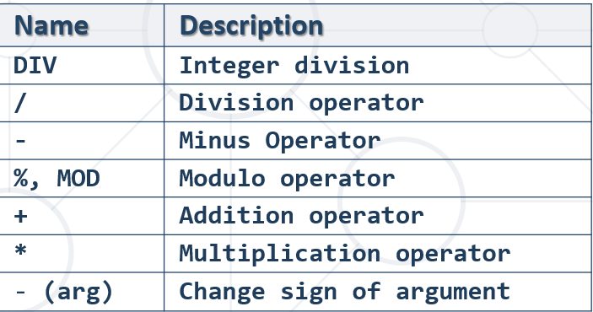

### Numeric Functions

Used primarily for numeric **manipulation** and/or mathematical **calculations**

* **PI** – get the value of Pi (15 –digit precision)

**SELECT PI**() +0.000000000000000

* **ABS** – absolute value

**ABS(***Value***)**

* **SQRT** – square root

**SQRT(***Value***)**

* **POW** – raise value to desired exponent

**POW(***Value*, *Exponent***)**

* The **SUM()** function returns the total sum of a numeric column.

SELECT ROUND(SUM(`cost`), 2) AS `total_sum` FROM `books`;

### Math Functions

* **CONV** – Converts numbers between different number bases

**CONV(***Value*, *from_base, to_base***)**

* **ROUND** – obtain desired precision

**ROUND(***Value*, *Precision***) –** Precision can be negative

SELECT **ROUND**(PI(), 2);

* **FLOOR** & **CEILING** – return the nearest integer

**FLOOR(***Value***) - надолу**

**CEILING(***Value***) - нагоре**

* **SIGN** – returns +1, -1 or 0, depending on value sign

**SIGN(***Value***)**

* **RAND** – get a random value in range [0,1)
  + If **Seed** is not specified, one is assigned at random – за хеширане, връща винаги една стойност за даден Seed

**RAND()** – връща random

**RAND(***Seed***) -** за хеширане, връща винаги една стойност за даден Seed

SELECT RAND('ssdfe'); винаги връща '0.15522042769493574'

## 3.3. Date Functions

* **EXTRACT** – extract a segment from a date as an integer

**EXTRACT(***Part* ***FROM*** *Date***)**

SELECT

**EXTRACT**(**DAY** FROM `born`) AS `day`,

`born` FROM `authors`;

SELECT EXTRACT(**YEAR** FROM '2022-05-23'); 2022

SELECT EXTRACT(**month** FROM '2022-05-23'); 5

SELECT EXTRACT(**day** FROM '2022-05-23'); 23

* **Get direct DAY, YEAR, MONTH, etc. without the function extract**

Директно си подаваме DAY, YEAR, MONTH от дадена дата

**DAY**(p.`date`) = 10

* **TIMESTAMPDIFF** – find difference between two dates

**TIMESTAMPDIFF(***Part, FirstDate, SecondDate***)**

* + ***Part*** can be any part and format of date or time

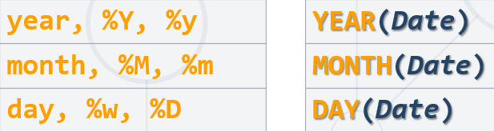

SELECT

**timestampdiff**(**MONTH**, `born`, `died`) AS `months_lived`,

`born` FROM `authors`;

* **DATE_FORMAT** – formats the date value according to the format

**SELECT DATE_FORMAT**('2017/05/31', '%Y %b %D') **AS** 'Date'**;**

SELECT DATE_FORMAT('2017/05/31 23:13:00', '%Y %b %D, %h:%i:%s') AS 'Date';

2017 May 31st, 11:13:00

Хардкорнати стойности %b за месец и %i за минута

SELECT `first_name` FROM `employees`

WHERE `department_id` IN(3, 10) && DATE_FORMAT(`hire_date`, '%Y') BETWEEN 1995 AND 2005

ORDER BY `employee_id`;

| **Specifier** | **Description** |
| --- | --- |
| %a | Abbreviated weekday name (Sun..Sat) |
| %b | Abbreviated month name (Jan..Dec) |
| %c | Month, numeric (0..12) |
| %D | Day of the month with English suffix (0th, 1st, 2nd, 3rd, …) |
| %d | Day of the month, numeric (00..31) |
| %e | Day of the month, numeric (0..31) |
| %f | Microseconds (000000..999999) |
| %H | Hour (00..23) |
| %h | Hour (01..12) |
| %I | Hour (01..12) |
| %i | Minutes, numeric (00..59) |
| %j | Day of year (001..366) |
| %k | Hour (0..23) |
| %l | Hour (1..12) |
| %M | Month name (January..December) |
| %m | Month, numeric (00..12) |
| %p | AM or PM |
| %r | Time, 12-hour (***hh:mm:ss*** followed by AM or PM) |
| %S | Seconds (00..59) |
| %s | Seconds (00..59) |
| %T | Time, 24-hour (***hh:mm:ss***) |
| %U | Week (00..53), where Sunday is the first day of the week; [WEEK()](https://dev.mysql.com/doc/refman/8.0/en/date-and-time-functions.html#function_week) mode 0 |
| %u | Week (00..53), where Monday is the first day of the week; [WEEK()](https://dev.mysql.com/doc/refman/8.0/en/date-and-time-functions.html#function_week) mode 1 |
| %V | Week (01..53), where Sunday is the first day of the week; [WEEK()](https://dev.mysql.com/doc/refman/8.0/en/date-and-time-functions.html#function_week) mode 2; used with %X |
| %v | Week (01..53), where Monday is the first day of the week; [WEEK()](https://dev.mysql.com/doc/refman/8.0/en/date-and-time-functions.html#function_week) mode 3; used with %x |
| %W | Weekday name (Sunday..Saturday) |
| %w | Day of the week (0=Sunday..6=Saturday) |
| %X | Year for the week where Sunday is the first day of the week, numeric, four digits; used with %V |
| %x | Year for the week, where Monday is the first day of the week, numeric, four digits; used with %v |
| %Y | Year, numeric, four digits |
| %y | Year, numeric (two digits) |
| %% | A literal % character |
| %***x*** | ***x***, for any “***x***” not listed above |

* **NOW** – obtain current date and time

**SELECT NOW();**

* **DATE_ADD**(`some_date`, **INTERVAL** *stepValue* *typeStep*)

SELECT `product_name`, `order_date`,

**DATE_ADD**(`order_date`, **INTERVAL** 3 **DAY**) AS 'pay_due'

FROM `orders`;

MINUTE

HOUR

DAY

WEEK

MONTH

QUARTER

YEAR

* Сравнение по дата

**SELECT** `deposit_group`, `is_deposit_expired`,

AVG(`deposit_interest`) AS `average_interest`

FROM `wizzard_deposits`

**WHERE `deposit_start_date` > '1985-01-01' когато формата на датата е този**

GROUP BY `deposit_group`, `is_deposit_expired`

ORDER BY `deposit_group` DESC, `is_deposit_expired` ASC;

<https://dev.mysql.com/doc/refman/8.0/en/date-and-time-functions.html>

## 3.4. Wildcards

### Системни команди / System commands – като сървър (а не като клиент)

USE **INFORMATION_SCHEMA**;

SELECT * from **statistics**;

SHOW **tables**;

### Вземи information данни за дадена таблица

**SELECT** `COLUMN_NAME` **FROM** `information_schema`.`columns`

**WHERE** `TABLE_SCHEMA` = 'custom-orm' **AND** `COLUMN_NAME` != 'id' **AND** `TABLE_NAME` = 'users';

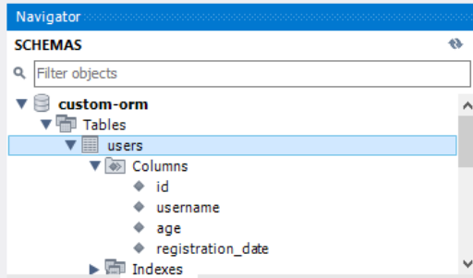 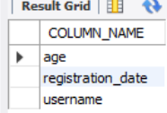

### Used to substitute any other character(s) in a string

* + **'%'** - represents zero, one, or multiple characters
  + **'_'** - represents a single character
  + Can be used in combinations
* Used with **LIKE** operator in a **WHERE** clause
  + Similar to **Regular Expressions**

SELECT * FROM `books`

WHERE `title` LIKE '____Big%';

SELECT `user_name`, `ip_address` FROM `users`

WHERE `ip_address` LIKE '___.1%.%.___' **три символа.1няколко символа.няколко символа.три символа**

ORDER BY `user_name` ASC;

* Find any values that start with "a"

**WHERE** CustomerName **LIKE** 'a%';

* Find any values that have "r" in second position

**WHERE** CustomerName **LIKE** '_r%'**;**

* Finds any values that starts with "a" and ends with "o"

**WHERE** ContactName **LIKE** 'a%o'**;**

* Supported characters also include – **част от regex нещата искат да опишат тук**
  + **\** – specify prefix to treat special characters as normal – да го escape-нем
  + [**charlist**] – specifying which characters to look for
    - [!**charlist**] – **excluding** characters

SELECT * FROM `books`

WHERE `title` **LIKE** '____Big**\%**'; - обикновен процент

SELECT `first_name`, `last_name` FROM `employees`

WHERE LOWER(`job_title`) **NOT LIKE** '%engineer%'

ORDER BY `employee_id`;

## 3.5. Regex

SELECT * FROM `customers`

WHERE `city` **REGEXP '[a-c]%'**; - a, b or c - връща 0 или 1 ца – дали има или няма match

Using regular expression

* **REGEXP** - pattern matching using regular expressions

SELECT `employee_id`, `first_name`, `last_name`

FROM `employees`

WHERE `first_name` **REGEXP '^\[^K\]{3}\$';** връща 0 или 1 ца – дали има или няма match

Пример:

DELIMITER $$$$

**CREATE FUNCTION** ufn_is_word_comprised(setOfLetters VARCHAR(45), word VARCHAR(45))

**RETURNS BIT //връща нула или единица, както и при BOOLEAN**

**DETERMINISTIC**

**BEGIN**

**RETURN** word **REGEXP(concat**('^[', setOfLetters, ']+$')**); //поне един път трябва да има всяк**

**END;**

**$$$$**

**SELECT** ufn_is_word_comprised('oistmiahf', 'Sofia');

**SELECT** ufn_is_word_comprised('oistmiahf', 'halves');

* [**REGEXP_SUBSTR**(***expr***, ***pat***[, ***pos***[, ***occurrence***[, ***match_type***]]])](https://dev.mysql.com/doc/refman/8.0/en/regexp.html#function_regexp-substr)

Returns the substring of the string ***expr*** that matches the regular expression specified by the pattern ***pat***, NULL if there is no match. If ***expr*** or ***pat*** is NULL, the return value is NULL.

[REGEXP_SUBSTR()](https://dev.mysql.com/doc/refman/8.0/en/regexp.html#function_regexp-substr) takes these optional arguments:

* ***pos***: The position in ***expr*** at which to start the search. If omitted, the default is 1.
* ***occurrence***: Which occurrence of a match to search for. If omitted, the default is 1.
* ***match_type***: A string that specifies how to perform matching. The meaning is as described for [REGEXP_LIKE()](https://dev.mysql.com/doc/refman/8.0/en/regexp.html#function_regexp-like).

**SELECT REGEXP_SUBSTR(**`title`, ' [a-zA-Z]{2} '**) AS `**match`, `title` **FROM** `books`;

SELECT REGEXP_SUBSTR(`title`, '[a-zA-Z]+') AS `match`, `title` FROM `books`;

* [REGEXP_REPLACE(***expr***, ***pat***, ***repl***[, ***pos***[, ***occurrence***[, ***match_type***]]])](https://dev.mysql.com/doc/refman/8.0/en/regexp.html#function_regexp-replace)

Replaces occurrences in the string ***expr*** that match the regular expression specified by the pattern ***pat*** with the replacement string ***repl***, and returns the resulting string. If ***expr***, ***pat***, or ***repl*** is NULL, the return value is NULL.

**SELECT**

user_name,

**REGEXP_REPLACE**(email, '.*@', '') **AS** 'email provider'

**FROM**

users;

## 3.6. Условни конструкции

##### Използване на IFNULL функцията - Return the specified value IF the expression is NULL, otherwise return the expression:

**IFNULL**(`middle_name`), '') - ако е NULL, то го замести с празен стринг, иначе върни полето

##### IF condition – 1 – **as a function – връща резултат**

IF(condition, value_if_true, value_if_false)

SELECT

`name` AS `game`,

/*DATE_FORMAT(start, '%k') AS `P`,*/

**IF**(DATE_FORMAT(start, '%k') >= 0 && DATE_FORMAT(start, '%k') < 12, 'Morning',

**IF**(DATE_FORMAT(start, '%k') >= 12 && DATE_FORMAT(start, '%k') < 18, 'Afternoon', 'Evening')) AS `Part of the Day`,

IF(`duration` <= 3 , 'Extra Short',

IF(`duration` <= 6, 'Short',

IF(`duration` <= 10, 'Long', 'Extra Long'))) AS `Duration`

FROM `games`;

##### IF condition – 2 – **as a statement – не връща стойност**

IF *search_condition* THEN *statement_list;*

[ELSEIF *search_condition* THEN *statement_list*] ...**;**

[ELSE *statement_list*]**;**

END IF

DELIMITER %%

CREATE PROCEDURE usp_raise_salary_by_id(id int)

BEGIN

START TRANSACTION;

**IF**((SELECT count(employee_id) FROM employees WHERE employee_id like id)<>1)

**THEN** ROLLBACK;

**ELSE**

UPDATE employees AS e SET salary = salary + salary*0.05

WHERE e.employee_id = id;

**END IF**;

END %%

**DECLARE** result DECIMAL;

**IF**(salary_emp < 30000) **THEN** **SET** result := 'Low'**; //при DECLARE използваме := за присвояване**

**ELSEIF** (salary_emp <= 50000) **THEN** **SET** result := 'Average'**; ELSEIF слято трябва да е**

**ELSE** **SET** result := 'High'**;**

**END IF;**

##### CASE condition - **as a function – връща резултат**

**Пример 1:**

SELECT

**CASE** `author_id`

**WHEN** 1 **THEN** 'Recommended for beginners' //Ако 1, върни еди какво си

**WHEN** 7 **THEN** 'Recommended for advanced'

**ELSE** 'All audiences'

**END**

AS `my_preference`

FROM `books`

WHERE SUBSTRING(title, 1, 3) = 'The';

**Пример 2:**

**SELECT** `name` AS 'game',

(**CASE** /*без променлива тук може*/

**WHEN** HOUR(`start`) **BETWEEN** 0 **AND** 11 **THEN** 'Morning'

**WHEN** HOUR(`start`) **BETWEEN** 12 **AND** 17 **THEN** 'Afternoon'

**ELSE** 'Evening'

**END**) **AS**  'Part of the Day',

(**CASE** /*без променлива тук може*/

**WHEN** `duration` **BETWEEN** 0 **AND** 3 **THEN** 'Extra Short'

**WHEN** `duration` **BETWEEN** 4 **AND** 6 **THEN** 'Short'

**WHEN** `duration` **BETWEEN** 7 **AND** 10 **THEN** 'Long'

**ELSE** 'Extra long'

**END**) **AS** 'Duration'

**FROM** `games`;

**Пример 3:**

SELECT

CASE

WHEN `age` BETWEEN 0 AND 10 THEN '[0-10]'

WHEN `age` BETWEEN 11 AND 20 THEN '[11-20]'

WHEN `age` BETWEEN 21 AND 30 THEN '[21-30]'

WHEN `age` BETWEEN 31 AND 40 THEN '[31-40]'

WHEN `age` BETWEEN 41 AND 50 THEN '[41-50]'

WHEN `age` BETWEEN 51 AND 60 THEN '[51-60]'

WHEN `age` >= 61 THEN '[61+]'

ELSE 'OUT of RANGE'

**END AS** **`age_group`,**

COUNT(`id`) AS `wizard_count`

FROM `wizzard_deposits`

**GROUP BY** **`age_group`**

ORDER BY `age_group`;

## 3.7. Цикли - **WHILE statement**

Пример с функция, където използваме **WHILE statement**

DELIMITER %%

CREATE FUNCTION ufn_IsWordComprised(setOfLetters VARCHAR (50), word VARCHAR (50))

RETURNS INT

deterministic

BEGIN

DECLARE index_letter INT;

DECLARE length_word INT;

DECLARE letter CHAR(1);

SET index_letter := 1;

SET length_word := CHAR_LENGTH(word);

**WHILE** (index_letter <= length_word)

**DO**

**SET** letter := SUBSTRING(word, index_letter, 1);

IF (LOCATE(letter, setOfLetters) > 0) **THEN SET** index_letter := index_letter + 1;

ELSE

RETURN 0;

END IF;

**END WHILE;**

RETURN 1;

END;

%%

**SELECT** ufn_IsWordComprised('oistmiahf', 'Sofia');

## 3.8. Цикли - **LOOP statement**

**LOOP**

...

-- terminate the loop

IF condition THEN

LEAVE [label];

END IF;

...

**END LOOP**;

# 4. Data Aggregation

## 4.1. Grouping - Consolidating Data Based On Criteria

* Grouping allows taking data into **separate groups** based on a **common property**

**SELECT** e.`job_title`, count(employee_id)

**FROM** `employees` **AS** e

**GROUP BY** e.`job_title`;

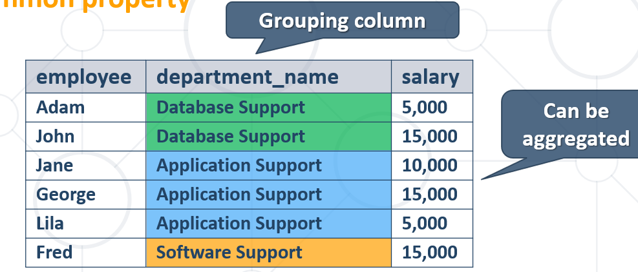

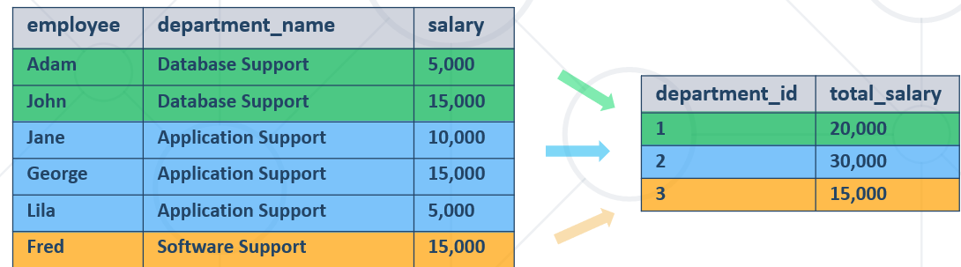

* **Групиране по 2 критерия**

SELECT

`deposit_group`,

`magic_wand_creator`,

**MIN**(`deposit_charge`) AS 'min_deposit_charge'

FROM

`wizzard_deposits`

**GROUP BY** `deposit_group` , `magic_wand_creator`

ORDER BY `magic_wand_creator` ASC , `deposit_group`;

* With **GROUP BY** you can get each separate group and use an **"aggregate" function** over it (like Average, Min or Max)

## 4.2. Aggregate Functions

* Used to operate over **one** or **more** groups performing **data** **analysis** on every one
  + MIN, MAX, **AVG**, COUNT etc.
* They usually **ignore** **NULL** values

### **COUNT -** counts the values (not nulls) in one or more columns based on grouping criteria

* Note that when we use **COUNT** we will ignore any employee with **NULL** salary.

SELECT `department_id`, **COUNT**(`first_name`) AS `Number of employees`

FROM `employees`

GROUP BY `department_id`

ORDER BY `department_id` ASC, `Number of employees` ASC;

**Използваме звезда за по-мързеливо и за да ни брои всички елементи**

SELECT `department_id`, **COUNT**(*) AS `Number of employees`

FROM `employees`

### **SUM** - sums the values in a column

* If any department has no salaries **NULL** will be displayed.

SELECT e.`department_id`,   
**SUM**(e.`salary`) **AS** 'TotalSalary'

FROM `employees` **AS** e

GROUP BY e.`department_id`;

### **MAX/MIN -** takes the maximum value in a column.

SELECT e.`department_id`,   
**MAX**(e.`salary`) **AS** 'Max Salary'

FROM `employees` **AS** e

GROUP BY e.`department_id`;

### **AVG** calculates the average value in a column.

SELECT e.`department_id`,

ROUND(**AVG**(e.`salary`),2) AS 'Average Salary'

FROM `employees` AS e

GROUP BY e.`department_id`

ORDER BY e.`department_id`;

Използване на AVG в секцията ORDER BY

**SELECT** w.`deposit_group`

**FROM** `wizzard_deposits` **AS** w

**GROUP BY** w.`deposit_group`

**ORDER BY AVG**(w.`magic_wand_size`)

**LIMIT** 1;

## 4.3. HAVING - Using Predicates While Grouping

**Having Clause**

* The **HAVING** clause is used to filter data based on **aggregate** values.
  + We cannot use it **without** grouping **before** that
* Any Aggregate functions in the "**HAVING**" clause and in the "**SELECT**" statement are executed one time only
* **Unlike HAVING, the WHERE clause filters rows before the aggregation**

**SELECT** `deposit_group`,

**SUM**(`deposit_amount`) AS `total_sum`

FROM `wizzard_deposits`

**WHERE** `magic_wand_creator` = 'Ollivander family'

**GROUP BY** `deposit_group`

**HAVING** `total_sum` < 150000

**ORDER BY** `total_sum` DESC;

**SELECT** `deposit_group`,

*

FROM `wizzard_deposits`

**WHERE** `magic_wand_creator` = 'Ollivander family'

**GROUP BY** `deposit_group`

**HAVING**  **SUM**(`deposit_amount`) < 150000

**ORDER BY** `total_sum` DESC;

Filter departments which have **total** salary **less than** 25,000.

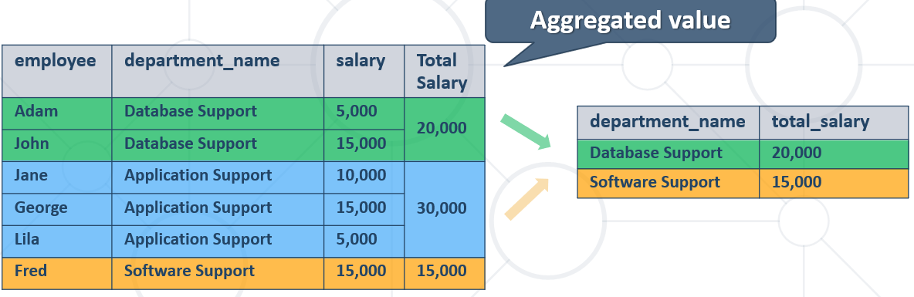

SELECT `department_id`,

SUM(`salary`) AS `TotalSalaryOfDepartment`

FROM `employees`

GROUP BY `department_id`

HAVING `TotalSalaryOfDepartment` < 120000;

## 4.4. MySQL **OFFSET and LIMIT** is used to specify which row should be fetched first.

SELECT e.`department_id`,

e.`salary` AS `third_highest_salary`

FROM `employees` AS e

WHERE (SELECT ine.`employee_id` FROM `employees` AS ine връща employee_id когато

WHERE ine.`department_id` = e.`department_id` департамента съвпада

GROUP BY ine.`salary` когато е третата най-висока заплата

ORDER BY `salary` DESC **LIMIT** 1 **OFFSET** 2 – **изкарай само един резултат, започвайки да търсиш след втория**

) = e.`employee_id` когато има съвпадение по employee_id

GROUP BY e.`department_id`

ORDER BY e.`department_id` ASC;

**LIMIT** **2, 1**; - започни да търсиш след втория запис, и ограничи до 1 запис изхода

## 4.5. Debug mode – EXPLAIN SELECT ..

**EXPLAIN SELECT** *, **SUBSTRING**(`title`, 1, 4) **FROM** `books` **LIMIT** 20 **OFFSET** 11;

**OFFSET** Отмести/започни от 11тия запис нататък

## 4.6. Вложени агрегиращи заявки

SELECT e.`first_name`, e.`last_name`, e.`department_id`

FROM `employees` AS e

WHERE e.`salary` > (

SELECT

AVG(inn.`salary`) FROM `employees` AS inn - намери средната заплата

WHERE inn.`department_id` = e.`department_id` - ако средната заплата след групиране отговаря на запла-

GROUP BY inn.`department_id` тата на всеки пореден служител от съотв. департамент

)

ORDER BY e.`department_id`, e.`employee_id`

LIMIT 10;

**Друго решение на същата задача – използваме сега само един Alias:**

**SELECT** `first**_**name`, `last**_**name`, `department**_**id`

**FROM** `employees` **AS** e

**WHERE** e.salary > (**SELECT** AVG(salary) **FROM** employees **WHERE** department_id = e.department_id **GROUP BY** department_id)

**ORDER BY** `department**_**id`, `employee**_**id`

**LIMIT** 10

**ВАЖНО – при update и използване на нестнати операции**

**UPDATE** employees_clients AS **ec**

SET ec.employee_id =

(

SELECT **ec**.employee_id – **от същата таблица ec реално**

GROUP BY **ec**.employee_id

ORDER BY COUNT(**ec**.employee_id) ASC, **ec**.employee_id ASC

LIMIT 1

)

WHERE ec.employee_id = ec.client_id;

## 4.7. Невложени заявки вършещи работа като вложени заявки

SELECT

SUM(`hw`.`deposit_amount` - `gw`.`deposit_amount`) AS 'sum_difference'

FROM

`wizzard_deposits` AS `hw`,

`wizzard_deposits` AS `gw`

WHERE

`gw`.`id` - `hw`.`id` = 1;

# 5. Table relations – видове връзки

## 5.1. Database design

**Steps in database design**

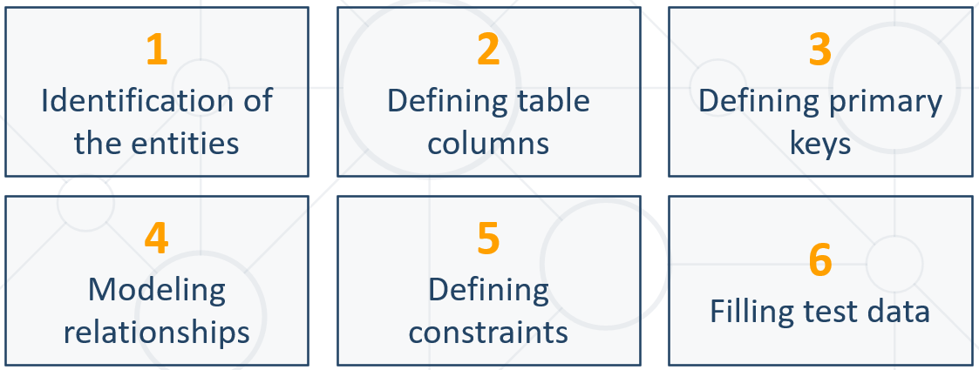

**1. Identification of Entities**

* Entity tables represent objects from the real world
  + Most often they are nouns in the specification

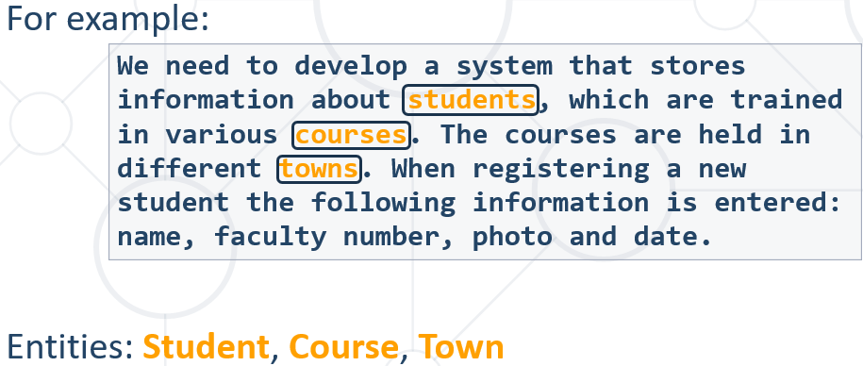

**2. Define Table Columns**

* Columns are clarifications for the entities in the text of the specification, for example:

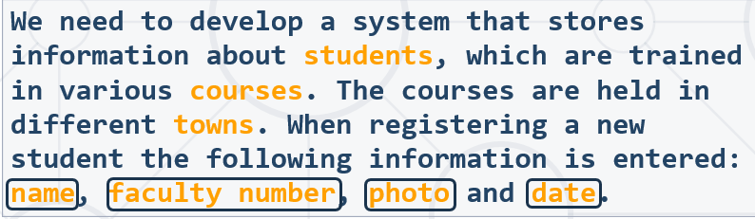

* Students have the following characteristics:
  + Name, faculty number, photo, date of enlistment and a list of courses they visit

**3. Defining primary keys**

* Always define an additional column for the primary key
  + Don't use an existing column (for example SSN)
  + Can be an integer number
  + **Must be** declared as **a PRIMARY KEY**
  + Use **AUTO_INCREMENT** to implement auto-increment
  + **Put the primary key as a first column**
* Exceptions
  + Entities that have well known ID, e.g. countries (BG, DE, US) and currencies (USD, EUR, BGN)

**4. Modelling relationships**

* Relationships are dependencies between the entities:

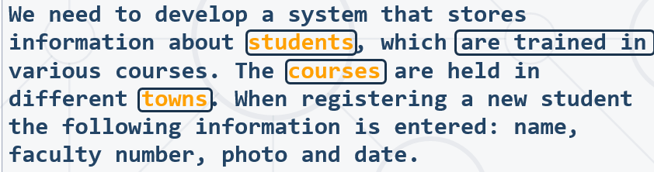

* + "Students are trained in courses" – **many-to-many** relationship.
  + "Courses are held in towns" – **many-to-one** (or many-to-many) relationship

**5. Defining constraints**

**6. Filling test data**

## 5.2. Table relations

* **Relationships** between tables are based on interconnections: **PRIMARY KEY** / **FOREIGN KEY**

**Foreign Key**

CREATE TABLE `Orders` (  
    `OrderID` int NOT NULL,  
    `OrderNumber` int NOT NULL,  
    `PersonID` int,  
    PRIMARY KEY (`OrderID`),

CONSTRAINT `fk_source_target`  
    FOREIGN KEY `Orders`(`PersonID`) REFERENCES `Persons`(`PersonID`)  
);

SQL FOREIGN KEY on ALTER TABLE

ALTER TABLE `products`

ADD CONSTRAINT `fk_products_categories` FOREIGN KEY `products`(`category_id`) REFERENCES `categories`(`id`);

* The **foreign key** is an **identifier** of a record located in another table (usually its primary key)
* By using relationships we avoid repeating data in the database
* Relationships have multiplicity:

### **One-to-many** – e.g. mountains / peaks - от едната страна на foreign key полето трябва да е UNIQUE

**Много модели на един производител в случая**

CREATE TABLE `**manufacturers**`(

`manufacturer_id` INT AUTO_INCREMENT PRIMARY KEY NOT NULL, **- реално е UNIQUE това поле**

`name` VARCHAR(45),

`established_on` DATE

);

**Foreign key е от Many страната на релацията.**

CREATE TABLE `**models**`(

`model_id` INT UNIQUE NOT NULL,

`name` VARCHAR(45),

`**manufacturer_id**` INT NOT NULL - **а това поле не е UNIQUE**

);

ALTER TABLE `**models**`

**ADD CONSTRAINT** `fk_models_manufacturers`

FOREIGN KEY `models`(`manufacturer_id`)

REFERENCES `manufacturers`(`manufacturer_id`);

INSERT INTO `manufacturers` (`name`, `established_on`)

VALUES

('BMW', '1916-03-01'),

('Tesla', '2003-01-01'),

('Lada', '1966-05-01');

INSERT INTO `models` (`model_id`, `name`, `manufacturer_id`)

VALUES

(101, 'X1', 1),

(102, 'i6', 1),

(103, 'Model S', 2),

(104, 'Model X', 2),

(105, 'Model 3', 2),

(106, 'Nova', 3);

### **One-to-one** – e.g. example driver / car – и от двете страни на foreign key полето трябва да е **UNIQUE**

CREATE TABLE `people`(

`person_id` INT AUTO_INCREMENT **PRIMARY KEY** NOT NULL,

`first_name` VARCHAR(45),

`salary` DECIMAL(10, 2) NOT NULL,

`passport_id` INT **UNIQUE** NOT NULL – **това поле е UNIQUE**

);

CREATE TABLE `passports`(

`passport_id` INT **UNIQUE** NOT NULL, - **и това поле също е UNIQUE**

`passport_number` VARCHAR(45) UNIQUE

);

ALTER TABLE `people`

**ADD CONSTRAINT** `fk_people_passports`

FOREIGN KEY `people`(`passport_id`)

REFERENCES `passports`(`passport_id`);

INSERT INTO `people` (`first_name`, `salary`, `passport_id`)

VALUES

('Roberto', 43300.00, 102),

('Tom', 56100.00, 103),

('Yana', 60200.00, 101);

INSERT INTO `passports` (`passport_id`, `passport_number`)

VALUES

(101, 'N34FG21B'),

(102, 'K65LO4R7'),

(103, 'ZE657QP2');

Всяко поле AUTO_INCREMENT и всяко поле PRIMERY KEY реално е **UNIQUE**

### **Many-to-many** – e.g. student / course – изпълнява се с **composite primary key и mapping table**

#### **Мapping table** and **composite primary key** - пример за **many-to-many relations**

CREATE TABLE `students`(

`student_id` INT AUTO_INCREMENT **PRIMARY KEY** NOT NULL,

`name` VARCHAR(45)

);

CREATE TABLE `exams` (

`exam_id` INT NOT NULL **PRIMARY KEY**,

`name` VARCHAR(30)

);

**Важно: за да работи foreign key, трябва да има primary key в таблиците**

CREATE TABLE `students_exams`(

`student_id` INT,

`exam_id` INT,

**CONSTRAINT** **pk**_students_exams

**PRIMARY KEY** `students_exams`(`student_id`, `exam_id`),

**CONSTRAINT** fk_students_exams_students

**FOREIGN KEY** `students_exams`(`student_id`)

**REFERENCES** `students`(`student_id`),

**CONSTRAINT** fk_students_exams_exams

**FOREIGN KEY** `students_exams`(`exam_id`)

**REFERENCES** `exams`(`exam_id`)

);

#### Без композитен ключ, използваме DISTINCT за да няма повторения

#08. Count Likes and Comments

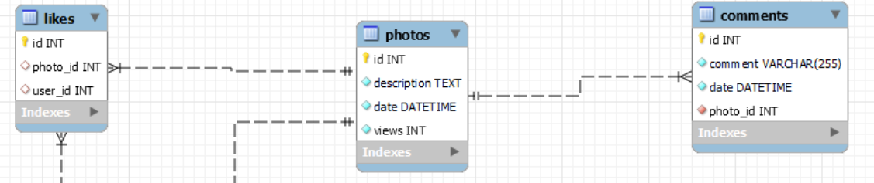

В случая, като съединим 3 таблици, и за всеки различен лайк на снимка има примерно по два коментара.

**Как процедираме – пускаме първо заявката със звезда, и виждаме какво става.**

**SELECT** *

**FROM** `photos` AS p

**LEFT JOIN** `likes` AS l

**ON** l.`photo_id` = p.`id`

**LEFT JOIN** `comments` AS c

**ON** c.`photo_id` = p.`id`;

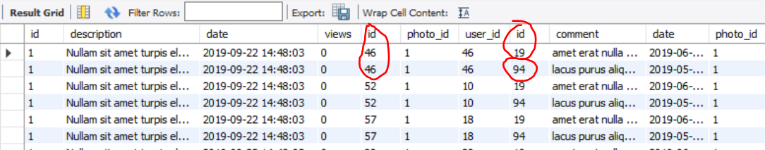

**SELECT** p.`id`, COUNT(**DISTINCT** l.`id`) **AS** `likes_count`, COUNT(**DISTINCT** c.`id`) **AS** `comments_count`

**FROM** `photos` **AS** p

**LEFT JOIN** `likes` **AS** l

**ON** l.`photo_id` = p.`id`

**LEFT JOIN** `comments` **AS** c

**ON** c.`photo_id` = p.`id`

**GROUP BY** p.`id`

**ORDER BY** `likes_count` DESC, `comments_count` DESC, p.`id` ASC;

### Self-referencing

CREATE TABLE `teachers`(

`teacher_id` INT PRIMARY KEY,

`name` VARCHAR(20),

`manager_id` INT,

**CONSTRAINT** fk_teachers_teachers

**FOREIGN KEY** `teachers`(`manager_id`)

**REFERENCES** `teachers`(`teacher_id`)

);

INSERT INTO `teachers` (`teacher_id`, `name`)

VALUES

(101, 'John'),

(102, 'Maya'),

(103, 'Silvia'),

(104, 'Ted'),

(105, 'Mark'),

(106, 'Greta');

UPDATE `teachers` SET `manager_id` = null WHERE (`name` = 'John');

UPDATE `teachers` SET `manager_id` = 106 WHERE (`name` = 'Maya');

UPDATE `teachers` SET `manager_id` = 106 WHERE (`name` = 'Silvia');

UPDATE `teachers` SET `manager_id` = 105 WHERE (`name` = 'Ted');

UPDATE `teachers` SET `manager_id` = 101 WHERE (`name` = 'Mark');

UPDATE `teachers` SET `manager_id` = 101 WHERE (`name` = 'Greta');

**Друг пример за self-referencing**

SELECT e.`employee_id`, e.`first_name`, m.`employee_id` AS 'manager_id', m.`first_name` AS 'manager_name'

**FROM** `employees` **AS** e

**JOIN** `employees` **AS** m

**ON** e.`manager_id` = m.`employee_id`;

## 5.3. JOIN - Retrieving Related Data

**Joins**

* Table relations are useful when combined with JOINS
* With JOINS we can get data from two tables **simultaneously**
  + JOINS require at least two tables and a "**join condition**"

Example:

SELECT * FROM table_a  
 **JOIN** table_b **ON** - добави таблица b към таблица а  
 table_b.common_column = table_a.common_column; **да са равни**

За използването на JOIN не е необходимо използването на външен ключ (foreign key)

**SELECT** v.`driver_id`, v.`vehicle_type`,

CONCAT(c.`first_name`, ' ', c.`last_name`) AS 'driver_name'

**FROM** `vehicles` **AS** v

**JOIN** `campers` **AS** c - добави таблица campers към таблица vehicles

**ON** v.`driver_id` = c.`id`;

## 5.4. Cascade Operations

* Cascading allows when a change is made to certain entity, this change to apply to all related entities

Ако изтриеш нещо, изтрий всичко по веригата.

Ако update-неш нещо, то го update-ни навсякъде по веригата.

### CASCADE DELETE

* **CASCADE** can be either **DELETE** or **UPDATE**.
* Use **CASCADE** **DELETE** when:
  + The related entities are **meaningless** without the "main" one
* Do **not** use **CASCADE** **DELETE** when:
  + You make "**logical delete**"
  + You preserve **history**
* Keep in mind that in more complicated relations it won't work with **circular** references

Пример 1:

* Write a query to create a one-to-many relationship
* When an mountains gets removed from the database, all of his peaks are deleted too

CREATE TABLE `mountains`(

`id` INT PRIMARY KEY AUTO_INCREMENT,

`name` VARCHAR(20) NOT NULL

);

CREATE TABLE `peaks`(

`id` INT PRIMARY KEY AUTO_INCREMENT,

`name` VARCHAR(20) NOT NULL,

`mountain_id` INT,

CONSTRAINT `fk_mountain_id`

FOREIGN KEY(`mountain_id`)

REFERENCES `mountains`(`id`)

**ON DELETE CASCADE**

);

Пример 2:

CREATE TABLE drivers(

driver_id INT PRIMARY KEY,

driver_name VARCHAR(50)

);

CREATE TABLE cars(

car_id INT PRIMARY KEY,

driver_id INT,

CONSTRAINT fk_car_driver FOREIGN KEY(driver_id)

REFERENCES drivers(driver_id) **ON DELETE CASCADE**  
);

### CASCADE UPDATE

* Use **CASCADE** **UPDATE** when:
  + The primary key is **NOT** identity (not **auto-increment**) and therefore it **can** be changed
  + Best used with **UNIQUE** constraint
* Do **not** use **CASCADE** **UPDATE** when:
  + The primary is identity (**auto-increment**)
* Cascading can be avoided using triggers or procedures

CREATE TABLE drivers(

driver_id INT PRIMARY KEY,

driver_name VARCHAR(50)

);

CREATE TABLE cars(

car_id INT PRIMARY KEY,

driver_id INT,

CONSTRAINT fk_car_driver FOREIGN KEY(driver_id)

REFERENCES drivers(driver_id) **ON UPDATE CASCADE**  
);

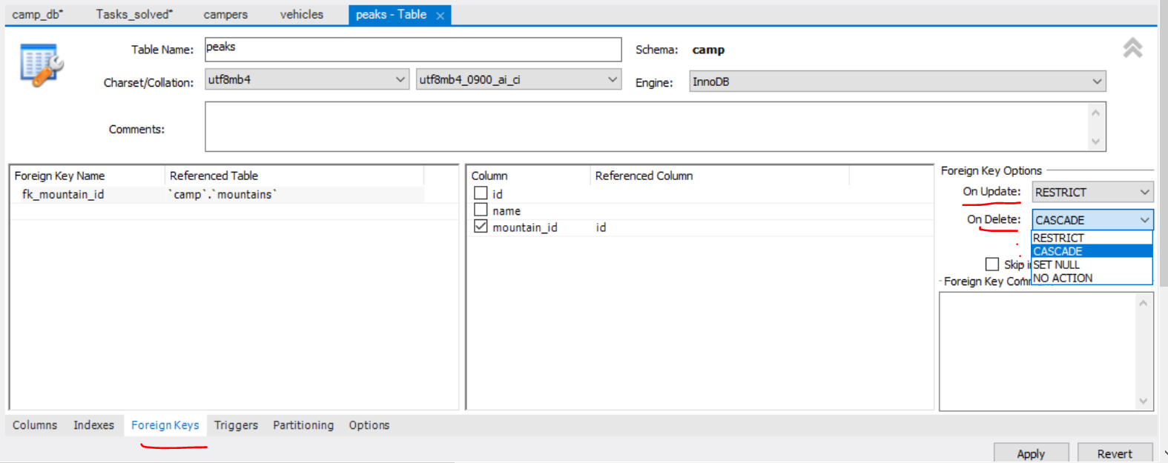

## 5.5. E/R Diagram

Понякога първо си чертаем E/R диаграмата, и след това пишем заявките

**Relational Schema**

* **Relational schema** of a DB is the collection of:
  + The schemas of all tables
  + Relationships between the tables
  + Any other database objects (e.g. constraints)
* The relational schema describes the **structure** of the database
  + Doesn't contain data, but **metadata**
* Relational schemas are **graphically** displayed in Entity / Relationship diagrams (**E/R Diagrams**)

### Reverse engineering



Добра практика е да слагаме префикс на името на всяка таблица, която създаваме. Например:

my_Products

my_Clients

my_personnel

или

wp_posts

wp_links

wp_commentmeta

wp_comments

wp_users

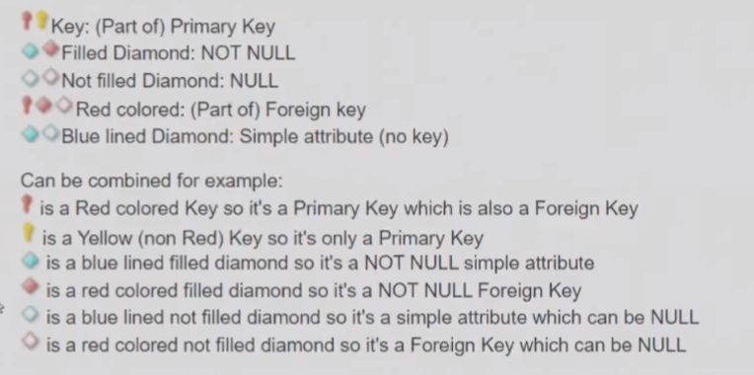

**В persons таблицата пишем дефиницията за foreign key**

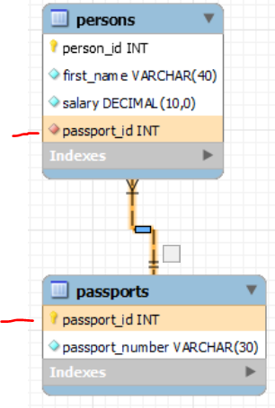

Като посочим стрелката, и ни показва кои полета са свързани.

**Как тълкуваме стрелката** - в случая таблица persons (parent) има foreign key passport_id, който сочи към таблица passports (child дете) с ключ passport_id (или passport_id на persons сочи към passport_id на passports).

Какво означава линията:

* + - **Плътна линия означава в двойката баща-дете, че и двете са задължителни/и двете са primary keys**
    - **Прекъсната линия означава, че в двойката parent-child не са задължителни и двете**

### Syncronize model – от E/R диаграма към създаване на база дани

Каквото сме си нарисували на диаграма, го направи на истинска база

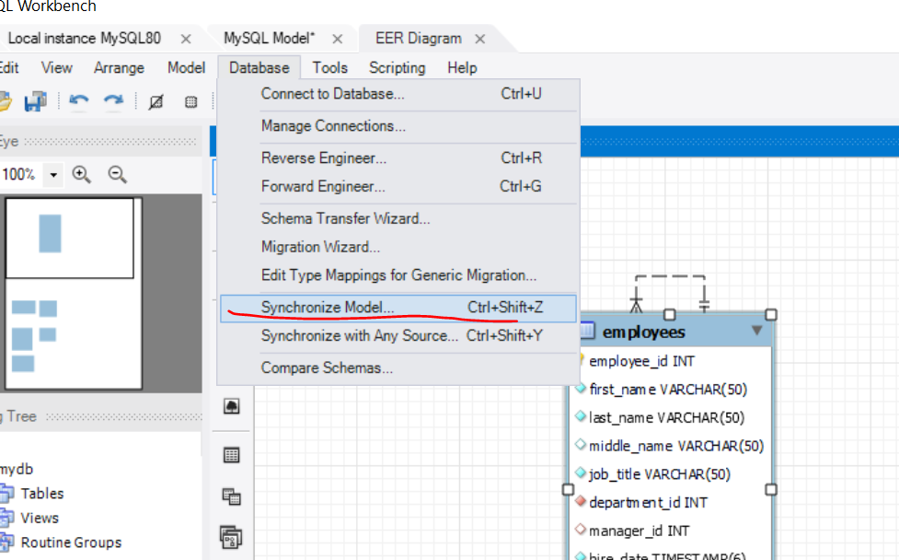

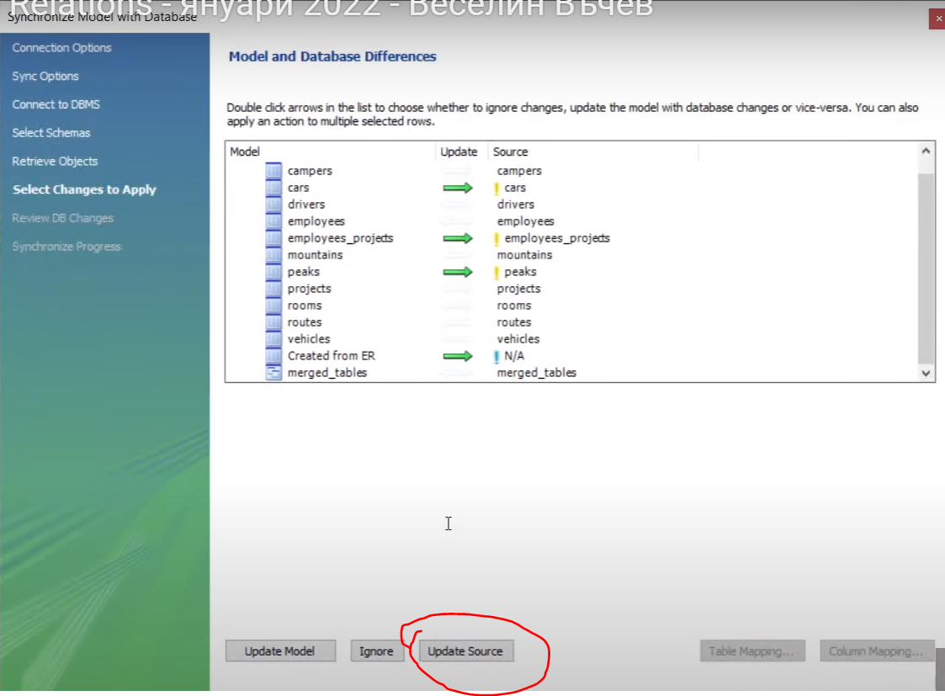

# 6. JOINS

## 6.1. Gathering Data From Multiple Tables

Можем да правим JOIN и на таблици без foreign keys

* Sometimes you need data from several tables:

**Cartesian product – всяко от едната таблица с всяко от другата таблица**

* Each row in the first table is paired with **all** the rows in the second table
  + When there is **no relationship** defined between the two tables

## 6.2. JOINS – used to collect data from **two** or **more** tables

* Types:

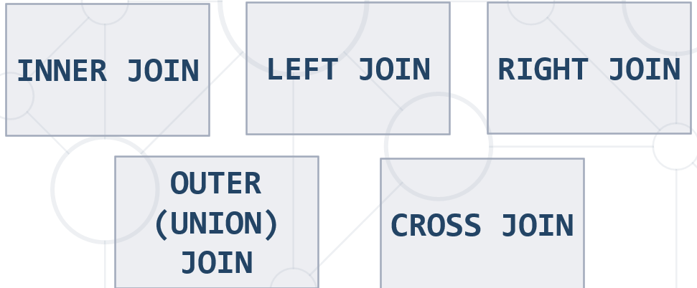

### **INNER JOIN = JOIN = взема сечението**

* Produces a set of records which **match in both tables**

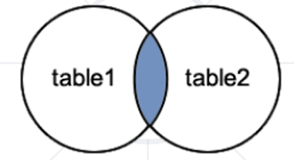

SELECT e.`first_name`, d.`name` AS 'dept_name'

FROM `employees` AS e **- таблица 1 = e**

**INNER JOIN** `departments` AS d **- таблица 2 = d**

**ON** e.`department_id` = d.`department_id`;

//Селектирай служителите, само които имат проекти

SELECT e.`employee_id`, e.`first_name`, p.`name` AS `project_name`

FROM `employees` AS e

**INNER JOIN** `employees_projects` AS ep

**ON** e.`employee_id` = ep.`employee_id`;

Или можем и така:

**SELECT** e.`employee_id`, e.`first_name`, p.`name` **AS** `project_name`

**FROM** `employees` **AS** e

**LEFT JOIN** `employees_projects` AS ep //вземи всичко отляво (таблицата employees като първа таблица)

**ON** e.`employee_id` = ep.`employee_id`

**WHERE** ep.`project_id` **IS NOT NULL**; //когато за employee_id от employees ИМА ep.`project_id`

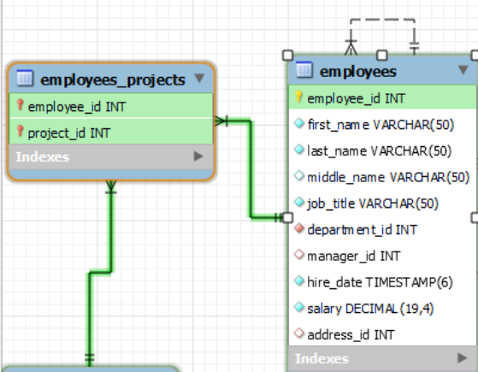

### **LEFT JOIN**

* Matches every entry in **left** table regardless of match in the **right**

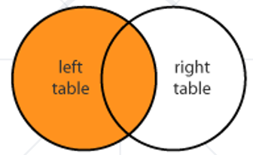

Example, see powerpoint presentation

Тези колеги, които не са в нито един проект

**SELECT** e.`employee_id`, e.`first_name`

**FROM** `employees` **AS** e

**LEFT JOIN** `employees_projects` **AS** ep //вземи всичко отляво (таблицата employees като първа таблица)

**ON** e.`employee_id` = ep.`employee_id`

**WHERE** ep.`project_id` **IS NULL** //когато за employee_id от employees няма ep.`project_id`

**ORDER BY** e.`employee_id` DESC

**LIMIT** 3;



### **RIGHT JOIN**

* Matches every entry in **right** table regardless of match in the **left**

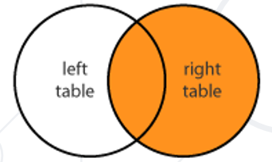

Example, see powerpoint presentation

### **OUTER (FULL JOIN)**

* Returns all records in both tables regardless of **any** match
  + Less useful than **INNER**, **LEFT** or **RIGHT** **JOINs** and it's **not implemented in MySQL**
  + We can use **UNION** of a **LEFT** and **RIGHT** **JOIN**

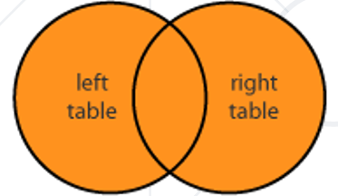

OUTER JOIN – взема всичко без сечението, но не е имплементирано в MySQL

### UNION of LEFT and RIGHT JOIN

SELECT students.name, courses.name

FROM students

**LEFT JOIN** courses

**ON** students.course_id = courses.id

**UNION**

SELECT students.name, courses.name

FROM students

**RIGHT JOIN** courses

**ON** students.course_id = courses.id

Example, see powerpoint presentation

### **CROSS JOIN**

* Produces a set of associated rows of two tables
  + Multiplication of each row in the first table with each in second
  + The result is a **Cartesian** product, when there's **no condition** in the **WHERE** clause

## 6.3. Subqueries – една заявка в друга заявка

* Subqueries – SQL query inside a larger one
* Can be nested in **SELECT, INSERT, UPDATE, DELETE**
  + Usually added within a **WHERE** clause

SELECT COUNT(e.employee_id) AS `count`

FROM employees AS e

WHERE e.salary >

(

SELECT AVG(salary) AS 'average_salary' FROM employees

);

**Конкатениране на повече от две таблици**

SELECT e.`first_name`, e.`last_name`, t.`name` , adr.`address_text`

**FROM** `employees` **AS** e

**JOIN** `addresses` **AS** adr

**ON** e.`address_id` = adr.`address_id`

**JOIN** `towns` **AS** t

**ON** adr.`town_id` = t.`town_id`

**ORDER BY** e.`first_name` ASC, e.`last_name` ASC

**LIMIT** 5;

**WHERE и ORDER BY ги слагаме след всички JOIN**

**SELECT** c.`country_code`, m.`mountain_range`, p.`peak_name`, p.`elevation`

**FROM** `countries` **AS** c

**JOIN** `mountains_countries` **AS** mc

**ON** c.`country_code` = mc.`country_code`

**JOIN** `mountains` **AS** m

**ON** mc.`mountain_id` = m.`id`

**JOIN** `peaks` AS p

**ON** m.`id` = p.`mountain_id`

**WHERE** c.`country_code` = 'BG' AND p.`elevation` > 2835

**ORDER BY** p.`elevation` DESC;

**Когато трябва да визуализираме променена стойност на дадена клетка**

SELECT e.`employee_id`, e.`first_name`,

(

CASE

WHEN YEAR(p.`start_date`) > 2004

THEN NULL - променената стойност е NULL

ELSE p.`name`

END

)

AS 'project_name'

FROM `employees` AS e

JOIN `employees_projects` AS ep

ON e.`employee_id` = ep.`employee_id`

JOIN `projects` AS p

ON p.`project_id` = ep.`project_id`

WHERE e.`employee_id` = 24

ORDER BY `project_name`;

**#15. *Continents and Currencies**

#групирана по два критерия връща за всеки континент и за всяка валута, то по колко пъти се използва дадена валута

**SELECT** contr.`continent_code`, contr.`currency_code`,

**COUNT**(*) **AS** `currency_usage`

**FROM** `countries` **AS** contr

**GROUP BY** contr.`continent_code` , contr.`currency_code`

**HAVING** `currency_usage` > 1 #всички валути, които се използват в даден континент в повече от една държава

**AND**

#от всички валути колко пъти са използвани, сравни само тази коя е използвана най-много пъти

`currency_usage` = (**SELECT** #c.`currency_code`,

**COUNT**(*) **AS** `most_used_currency`

**FROM** `countries` **AS** c

**WHERE** c.`continent_code` = contr.`continent_code`

**GROUP BY** c.`currency_code`

**ORDER BY** `most_used_currency` **DESC**

**LIMIT** 1)

**ORDER BY** contr.`continent_code` **ASC**, contr.`currency_code` **ASC**;

## 6.4. More hacks

### UPDATE JOIN

#Task 3 - Update - version in which we have employees with 0 clients – вложена заявка

**UPDATE** employees_clients **AS** ec

**SET** ec.employee_id =

(

SELECT COUNT(e.id) FROM employees AS e

LEFT JOIN **(SELECT * from employees_clients)** AS emcl **- нова инстанция на същата таблица**

ON emcl.employee_id = e.id

GROUP BY e.id

ORDER BY COUNT(e.id) ASC, e.id ASC

LIMIT 1

)

WHERE ec.employee_id = ec.client_id;

Или така също става

**UPDATE** `products` **AS** prr

**JOIN** `categories` **AS** c

**ON** prr.`category_id` = c.`id`

**JOIN** `reviews` AS r

**ON** r.`id` = prr.`review_id`

**SET** prr.`price` = prr.`price` * 0.7

**WHERE** c.`name` = 'Phones and tablets' AND r.`rating` < 4;

### DELETE JOIN

**Вариант 1 - Работи**

**DELETE** emp **FROM** employees **AS** emp **– изтрий от таблицa emp**

**LEFT JOIN** employees_clients **AS** ec

**ON** ec.employee_id = emp.id

**WHERE** ec.client_id **IS NULL**; - тези, служители, които нямат клиенти, при JOIN имат cliend_id да е NULL

Вариант 2

DELETE FROM employees WHERE id = **– изтрий от таблицa emp**

(

SELECT emp.id FROM **(SELECT * FROM employees)** AS emp **- нова инстанция на същата таблица**

**LEFT JOIN** employees_clients AS ec

**ON** ec.employee_id = emp.id

**WHERE** ec.client_id **IS NULL** - тези, служители, които нямат клиенти, при JOIN имат cliend_id да е NULL

)

### GROUP BY plus JOIN

SELECT CONCAT(emp.first_name, ' ', emp.last_name) AS 'name',

emp.started_on,

COUNT(ec.employee_id) AS count_of_clients

FROM employees AS emp

LEFT **JOIN** employees_clients AS ec

ON ec.employee_id = emp.id

**GROUP BY** ec.employee_id

ORDER BY count_of_clients DESC, emp.id ASC

LIMIT 5;

## 6.4. Indices и балансирано бинарно дърво

* Structures associated with a table or view that speeds retrieval of rows
  + Usually implemented as **B-trees**
* Indices can be built-in the table (**clustered**) or stored externally (**non-clustered**)
* Adding and deleting records in indexed tables is slower!
  + Indices should be used for big tables only (e.g. 50 000 rows)

Когато имаме много на брой данни, в даден момент се налага преиндексиране на базата данни, за да се постигне балансирано бинарно дърво.

Небалансираното дърво забавя много операциите.



### Clustered Indices

* **Clustered index determine the order of data**
  + Very useful for fast execution of **WHERE**, **ORDER BY** and **GROUP BY** clauses
* Maximum 1 clustered index per table
  + If a table has no clustered index, its data rows are stored in an **unordered structure** (heap)

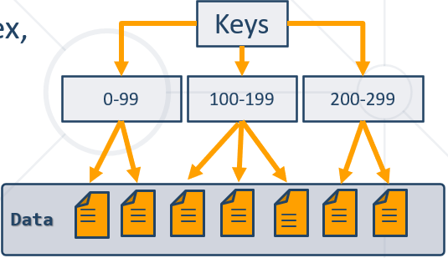

### Non-Clustered Indices

* Useful for fast retrieving a **single record** or a **range** of records
  + Each **key value entry** has a pointer to the data row that contains the key value
* Maintained in a separate structure in the DB

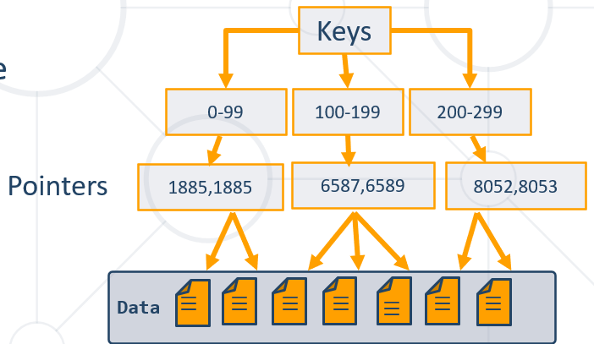

Синтаксис на индекс

**CREATE INDEX**

ix_users_first_name_last_name

**ON** `users`(`first_name`, `last_name`);

# 7. Database Programmability

Да избягваме в практиката функции и процедури в MySQL

**Важно: ПЪРВО разписваме проста заявка, и след това я копираме/слагаме в структурата на съответната функция/процедура/тригер**

**We can optimize with User-defined Functions.**

**Transactions improve security and consistency.**

**Stored Procedures encapsulate repetitive logic.**

**Triggers execute before certain events on tables.**

## 7.1. User-Defined Functions

Encapsulating Custom Logic

* Extend the functionality of a MySQL Server
  + **Modular=functional** programming – write **once**, call it **any number** of times
  + Faster execution – doesn't need to be reparsed and reoptimized with each use
  + Break out complex logic into **shorter code blocks**
* Functions can be:
  + Scalar – return **single value** or **NULL**
  + Table-Valued – return a **table**

Само при използване на **DECLARE** използваме за присвояване/задаване на стойност **:=**

**DRY – Don’t Repeat Yourself** принцип

### Creating Functions

**DELIMITER** $$$$ - **начало на разделител**

**CREATE FUNCTION** ufn_count_employees_by_town(`town_name` **VARCHAR(20)**)

**RETURNS** DOUBLE - **какъв тип връща функцията, незадължителен елемент**

**DETERMINISTIC – при едни и същи входни данни един и същи резултат връща**

**BEGIN**

**DECLARE** e_count DOUBLE; - **деклариране на променлива**

**SET** e_count **:=** (SELECT COUNT(employee_id) FROM employees AS e - **за присвояване**

INNER JOIN addresses AS a ON a.address_id = e.address_id

INNER JOIN towns AS t ON t.town_id = a.town_id

WHERE t.name = town_name);

**RETURN** e_count; - **каква стойност връща функцията, незадължителен елемент**

**END**;

$$$$ - **край на разделител**

DELIMITER $$$$

CREATE FUNCTION ufn_count_employees_by_town(`town_name` VARCHAR(20))

RETURNS INT

DETERMINISTIC

BEGIN

DECLARE e_count INT;

SET e_count **:=** (SELECT COUNT(e.`employee_id`) FROM `employees` AS e

INNER JOIN `addresses` AS a ON a.`address_id` = e.`address_id`

INNER JOIN `towns` AS t ON t.`town_id` = a.`town_id`

WHERE t.`name` = `town_name`);

RETURN e_count;

Или директно връщаме резултата

RETURN(

(SELECT COUNT(e.`employee_id`) FROM `employees` AS e

INNER JOIN `addresses` AS a ON a.`address_id` = e.`address_id`

INNER JOIN `towns` AS t ON t.`town_id` = a.`town_id`

WHERE t.`name` = `town_name`));

END;

$$$$

Deterministic vs. non-deterministic functions

### Executing and Dropping Stored Functions

**И така изпълняваме функцията**

**SELECT** ufn_count_employees_by_town('Sofia');

**SELECT** ufn_get_salary_level(51000.0);

**DROP FUNCTION** ufn_get_salary_level;

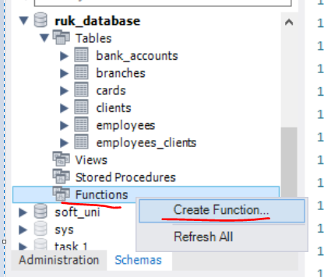

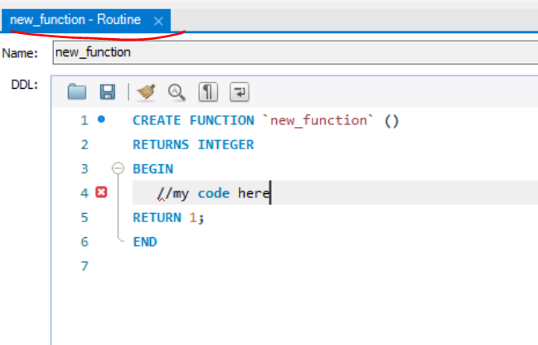

## 7.2. Stored Procedures

Sets of Queries Stored On DB Server

* Stored procedures are logic removed from the application and placed on the database server.
  + Can greatly cut down traffic on the network
  + Improve the security of the database server
  + Separate data access routines from the business logic
* Stored procedures are accessed by programs using different platforms and API's.
* **Нямаме return при процедури**

### Creating Stored Procedures

**DELIMITER %%**

**CREATE PROCEDURE** usp_select_employees_by_seniority()

**BEGIN**

SELECT *

FROM employees

WHERE ROUND((DATEDIFF(NOW(), hire_date) / 365.25)) < 15;

**END %%**

### Executing and Dropping Stored Procedures

* Executing a stored procedure by **CALL**

**CALL** usp_select_employees_by_seniority();

* **DROP PROCEDURE**

**DROP PROCEDURE** usp_select_employees_by_seniority;

### Defining Parameterized Procedures

* To define a parameterized procedure use the syntax:

**CREATE PROCEDURE** usp_procedure_name

(parameter_1_name parameter_type,

parameter_2_name parameter_type,…)

**Пример 1:**

DELIMITER $$

CREATE PROCEDURE usp_select_employees_by_seniority(min_years_at_work INT)

BEGIN

SELECT first_name, last_name, hire_date,

ROUND(DATEDIFF(NOW(),DATE(hire_date)) / 365.25,0) AS 'years'

FROM employees

WHERE ROUND(DATEDIFF(NOW(),DATE(hire_date)) / 365.25,0) > min_years_at_work

ORDER BY hire_date;

END $$

CALL usp_select_employees_by_seniority(15);

**Пример 2:**

Task 2 -Employees Promotion

DELIMITER $

CREATE PROCEDURE usp_raise_salaries (dept_name VARCHAR(45))

BEGIN

/*business logic*/

UPDATE `employees` AS e

JOIN `departments` AS d

ON d.`department_id` = e.`department_id`

SET e.`salary` = e.`salary` * 1.05

WHERE d.`name` = dept_name;

SELECT e.`first_name`, e.`salary` FROM `employees` AS e

JOIN `departments` AS d

ON d.`department_id` = e.`department_id`

WHERE d.`name` = dept_name

ORDER BY e.`first_name`, e.`salary`;

END $

CALL usp_raise_salaries('Finance');

Пример 3:

DELIMITER %%%

CREATE PROCEDURE usp_get_towns_starting_with (starts_with VARCHAR(20))

BEGIN

SELECT `name` FROM `towns`

WHERE `name` **LIKE** **concat**(starts_with, '%') - **тук конкатенираме**

ORDER BY `name`;

END; %%%

CALL usp_get_towns_starting_with('S');

### Returning Values Using OUTPUT Parameters

DELIMITER $$

**CREATE PROCEDURE** usp_add_numbers (first_number INT, second_number INT, **OUT** **result** INT)

**BEGIN**

**SET** **result** = first_number + second_number;

END $$

**Все едно процедурата работи като функция:**

**SET** **@**answer=0;

**CALL** usp_add_numbers(5, 6,**@**answer);

SELECT **@**answer;

Функции и процедури рядко се използват – те са бизнес логика, която не е редно да стои при базата данни на сървъра.

## 7.3. Transactions – a kind of a stored procedure

* Една процедура има една или няколко SQL заявки, които се изпълняват една след друга.
* При транзакции, може да се създаде логика, която да изпълнява една или друга заявка или всички заявки, ИЛИ никоя от заявките да не се изпълни
* Transaction is a **sequence of actions SQL queries** (database operations) executed as a whole
  + Either **all** of them complete successfully or **none** of them
* Example of transaction
  + A bank transfer from one account into another (withdrawal + deposit)
    - If either the withdrawal or the deposit fails **the whole operation is cancelled**
* Транзакцията се пише вътре в процедура(stored procedure)
* Ако имаме много заявки, и ако някоя се чупи, то можем да зададем ROLLBACK и на всички изпълнени до момента транзакции

**ACID model is used by InnoDB engine на MySQL**

**Transactions Behavior**

* Transactions guarantee the **consistency** and the **integrity** of the database.
  + All changes in a transaction are temporary
  + Changes are persisted when **COMMIT** is executed – всичко е временно докато не commit-нем

COMMIT е зададен като default - да

* + At any time all changes can be canceled by **ROLLBACK**
* All of the operations are executed as a whole.

Само намаля в случая:

**START TRANSACTION;**

UPDATE `employees` SET `salary` = `salary` - 1000 WHERE `employee_id` = 1;

Отново само намаля в случая:

**START TRANSACTION;**

UPDATE `employees` SET `salary` = `salary` - 1000 WHERE `employee_id` = 1;

**COMMIT;**

Намалянето не се извършва:

**START TRANSACTION;**

**UPDATE** `employees` **SET** `salary` = `salary` - 1000 **WHERE** `employee_id` = 1;

**ROLLBACK;**

#Task 3

DELIMITER %%

**CREATE PROCEDURE** usp_raise_salary_by_id(id int)

**BEGIN**

**DECLARE** does_exist INT;

**START TRANSACTION**;

**UPDATE** employees SET salary = salary *1.05 WHERE employee_id = id; - **update-ни всички, но не записвай нищо още реално**

SET does_exist **:=** (SELECT COUNT(*) FROM employees WHERE employee_id = id);

**IF** (does_exist = 1)

**THEN** **COMMIT**; **- сега ги презапиши!!!**

**ELSE**

**ROLLBACK**;

**END IF**;

**END** %%

**CALL** usp_raise_salary_by_id(1);

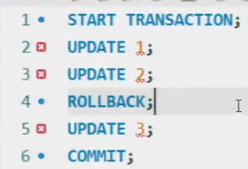

Modern DBMS servers have built-in transaction support

* + Implement "ACID" transaction
  + hgfds
* ACID means:
  + **A**tomicity
  + **C**onsistency
  + **I**solation
  + **D**urability

#13. Withdraw Money

DELIMITER $$$

**CREATE PROCEDURE** usp_withdraw_money(account_id INT, money_amount DECIMAL(19, 4))

**BEGIN**

DECLARE bal DECIMAL(19, 4);

START TRANSACTION;

SET bal := (SELECT a.`balance` FROM `accounts` AS a WHERE a.`id` = account_id) - money_amount;

UPDATE `accounts`

SET `balance` = `balance` - money_amount

WHERE `id` = account_id;

**IF** (money_amount > 0 AND bal > **0.0000**) **THEN COMMIT**;

**ELSE ROLLBACK;**

**END IF;**

**END;**

$$$

DROP PROCEDURE usp_withdraw_money;

CALL usp_withdraw_money(1, 20);

## 7.4. Triggers – като Event Listener

Event-listener – чакаме нещо да се случи, и тогава прави нещо

* Triggers - small programs in the database itself, activated by the database events application layer
  + UPDATE, DELETE or INSERT queries
  + Called in case of specific **event**
* We do not call triggers **explicitly**
* Triggers are **attached** to a table

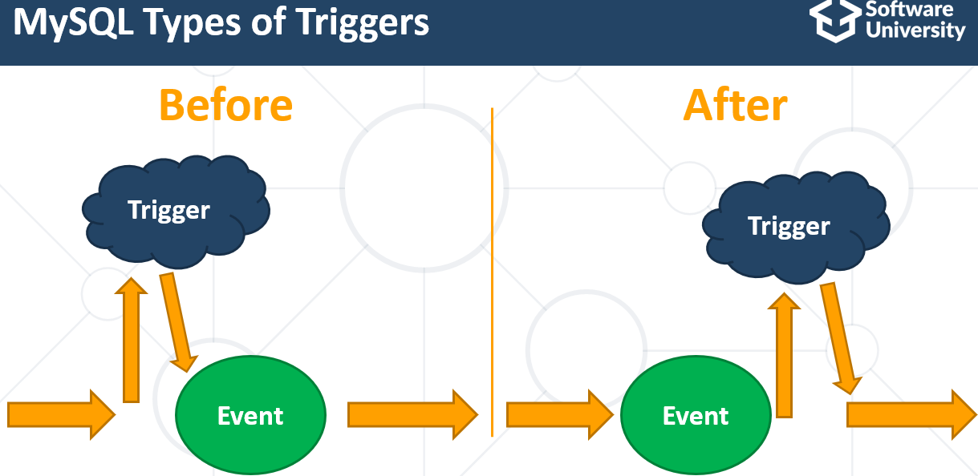

There are three different events that can be applied within a trigger:

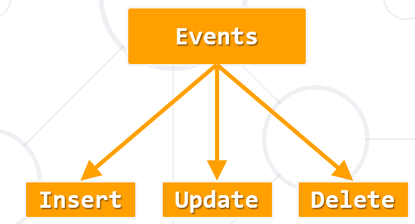

The OLD and NEW keywords allow you to access columns before/after trigger action

OLD – **before trigger action – използва се при AFTER events**

NEW – **after trigger action – използва се при BEFORE events**

### After Delete

**CREATE TABLE** deleted_employees(

employee_id INT PRIMARY KEY AUTO_INCREMENT,

first_name VARCHAR(20),

last_name VARCHAR(20),

middle_name VARCHAR(20),

job_title VARCHAR(50),

department_id INT,

salary DOUBLE

);

**CREATE TRIGGER** tr_deleted_employees

**AFTER DELETE**

**ON** employees

**FOR EACH ROW**

**INSERT INTO** **deleted_employees** (first_name,last_name,middle_name,job_title,department_id,salary)

**VALUES**(OLD.first_name, OLD.last_name, OLD.middle_name, OLD.job_title, OLD.department_id, OLD.salary);

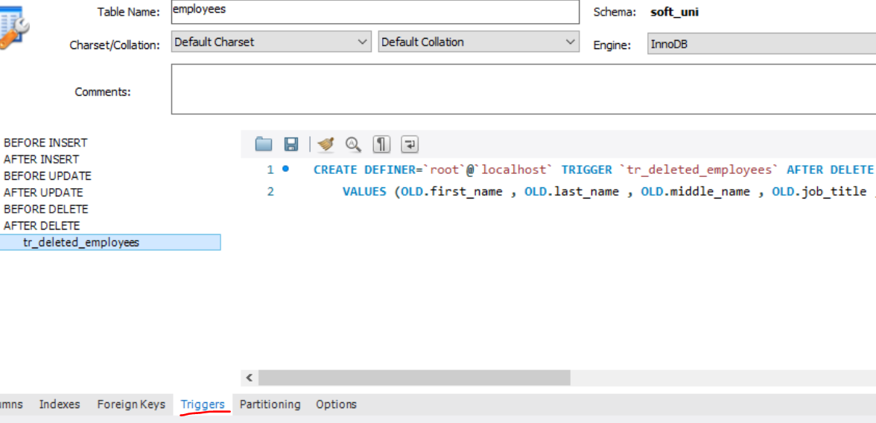

### Before Insert

CREATE TRIGGER trigger_employee

**BEFORE INSERT**

ON `employees`

FOR EACH ROW

BEGIN

END;

### After Update

**CREATE** DEFINER = CURRENT_USER **TRIGGER** `employee_AFTER_UPDATE` **AFTER UPDATE**

**ON** `employees`

**FOR EACH ROW**

INSERT INTO addresses_archive (old_salary, new_salary) VALUES (**OLD.salary**, **NEW.salary**)

INSERT INTO LOGS addresses_archive (old_salary, new_salary) VALUES (**OLD.salary**, **NEW.salary**)

За по-лесно, може да ползваме и този прозорец

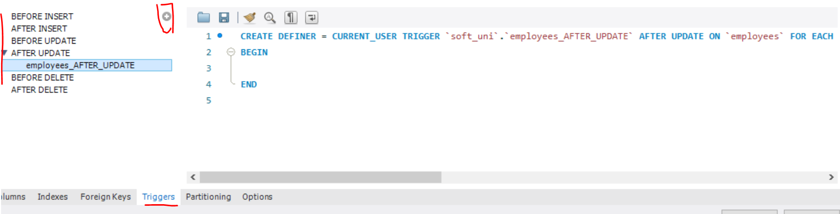

#15. Log Accounts Trigger

CREATE TABLE `logs`(

`log_id` INT PRIMARY KEY AUTO_INCREMENT,

`account_id` INT NULL,

`old_sum` DECIMAL(19, 4) NOT NULL,

`new_sum` DECIMAL(19, 4) NOT NULL);

DELIMITER $$

**CREATE TRIGGER** `tr_balance_updated`

**AFTER UPDATE ON** `accounts`

**FOR EACH ROW**

**BEGIN -** пишем го след FOR EACH ROW

**IF OLD**.`balance` != **NEW**.`balance` **THEN**

**INSERT INTO** `logs`(`account_id`, `old_sum`, `new_sum`) **VALUES** (OLD.`id`, OLD.`balance`, NEW.`balance`);

**END IF;**

**END;**$$

**DROP TRIGGER** `tr_balance_updated`;

Тази проверка е излишна, освен разбира се ако има промяна не в баланса, а в други данни

#IF OLD.`balance` != NEW.`balance` THEN

#END IF;

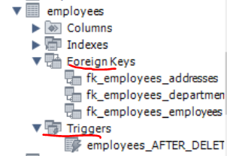

CREATE TABLE IF NOT EXISTS `accounts` (

**`id`** int(11) NOT NULL,

`account_holder_id` int(11) NOT NULL,

**`balance`** decimal(19,4) DEFAULT '0.0000',

PRIMARY KEY (`id`),

CREATE TABLE logs(

**log_id** INT PRIMARY KEY AUTO_INCREMENT,

**account_id** INT,

**old_sum** DECIMAL(19, 4),

**new_sum** DECIMAL(19, 4)

);

**CREATE** DEFINER=`root`@`localhost` **TRIGGER** `accounts_AFTER_UPDATE`

**AFTER UPDATE**

**ON** `accounts` **FOR EACH ROW**

INSERT INTO **`logs`** (`account_id`, `old_sum`, `new_sum`) - **вкарай в новата таблица `logs`**

VALUES (OLD.`id`, OLD.`balance`, NEW.`balance`); - **вземи данни от таблица `accounts` където правим промени**

## 7.5. Глобални настройки / стойности

### За смяна на root паролата

ALTER USER 'root'@'localhost' IDENTIFIED BY '';

flush privileges;

### За проверка свързана с външни ключове

#Игнорирай външните ключове, за да можем да си трием спокойно :)

**SET** FOREIGN_KEY_CHECKS = 0;

#Имай в предвид външните ключове

**SET** FOREIGN_KEY_CHECKS = 1;

### Общи

**SET GLOBAL** log_bin_trust_function_creators = 1; //да се доверявам на функциите ако аз съм ги създал

**SET** SQL_SAFE_UPDATES = 0; //да махнем safe updates

**SELECT** @@sql_mode;

**SET** sql_mode = 'ONLY_FULL_GROUP_BY'; **- активен този mode**

**SET** sql_mode = '';- премахни only full group by – да го използваме в Judge, но няма ефект ☹

**Има промяна в Judge – Judge работи вече само в mode 'ONLY_FULL_GROUP_BY'**

**Когато групираме по PRIMARY KEY, няма проблеми обаче!!!**

**Друг вариант е да използваме вложени заявки и да не използваме GROUP BY!!!**

**GROUP_CONCAT**

**ANY_VALUE**(muhaha) **AS** `bla_bla_bla`;

# 8. Нормализация на базите данни

<https://bg.myservername.com/database-normalization-tutorial>

# 9. Other

Ако искаме, можем да ползваме и XAMPP или MariaDB или Heidi SQL вместо MySQL

